Five Pillars of Ministry Formation
A Visual Guide to Presence-Based Discipleship


- Spiritual Formation Happens Through Shared Sacred Moments



- Relational Discipleship Is Built on Presence, Not Just Teaching

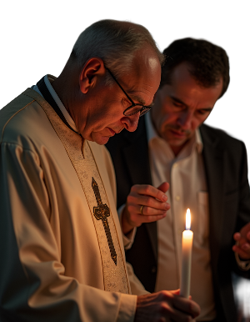

- Emotional Intelligence Grows Through Reflection on Real Encounters



- Incarnational Leadership Emerges in Local, Seasonal Way



- Volunteer Sustainability Increases When People Serve Out of Passion, Not Pressure

