Unit 11
Polynomial Notation
As impressive and exotic as the title for the math is, here, it’s nothing strange: you’ve been using polynomial notation as long as you have been using numbers, without using the name. You’ll recall talking about the ones digit, the tens digit, the hundreds digit, and so forth, as well as the tenths digit, the hundredths digit, et cetera. Each digit in the number multiplies ten to some power. In fact, if we let a_{i} represent the digit involved in the i^{th} digit of the number, the number can be represented thus:
n =
You will, I hope, recall that I mentioned there were plenty of zeros involved in writing out numbers and decimal fractions: you can tell that almost all of the a_{i} are zero. This is, I suppose, why those of us that enjoy mathematics keep barrels full of zeros available to use. Maybe I’m exaggerating a little on that point.
All of this raises the question as to whether there is anything unique about the number ten. To be honest, other than it is the number of fingers and thumbs we have on our two hands—which has been suggested by some as the reason why we use ten as the base of our number system. The Mayans, by the way, used a number system based on twenty: they must have noticed their toes. What it was about the Babylonians, I don’t know, but they worked with a numbering system based on 60, which is why we have 60 seconds to the minute and 60 seconds to the hour. The Oksapmin use 27 the way we use 10, the Ndom use 6, the Huli use 15. There is a whole society based on the idea that we should go from a decimal, or base 10, system of counting to one based on the number 12. Computers work in binary—that uses 2 the way we use 10—and computer scientists will often work in hexadecimal, which uses 16 the way we use the number 10. In any system of polynomial notation, there is some number that is the basis for the system, and a group of specific digits, ranging from zero to one less than the basis of the system, that are used as multipliers. Formally, that means for any integer x, you can create a numerical system so that the number n is uniquely expressed by:
n =
Bewildering as that may seem, by the way, polynomial notation is not the only means of representing numbers that exists—but polynomial notation is quite enough for this course.
Just as a notational aside, for bases greater than 10, the a_{i} over 9 are usually represented by capital letters in the alphabet. So, in base 16, 10 is A, 11 is B, 12 is C and so on. There are other ways that I have seen this done, but there’s no sense adding to the confusion by listing them.
Everything you have learned about adding, subtracting, multiplying and dividing work the same in any base as they do in base 10. Adjustments for multiplying the a_{i} or adding/subtracting them in the new base need made—in base 2, 1+1 = 10, for instance, and 2 x 2 = 100—but other than that, it’s all the same.
In the context of using different bases, by the way, it is customary to write the non-decimal base subscripted at the end of the number, to alert the individual reading it that the given number is not in the decimal system. So, 50₁₀ is 32₁₆ for instance—a joyous observation for those who dread turning 50. And 67₁₀ is 43₁₆ which makes us oldsters feel a little younger, even if unjustly.
The question of how to convert numbers in decimal to numbers in another base, and how to convert them back, comes to mind. It’s not really all that hard to do: I set up an EXCEL spreadsheet to do decimal to whatever base in about 3 minutes, then took another 4 or 5 minutes to use it to created your homework assignment. Here’s how you do the conversion. Start by taking the number in base 10 and dividing it by whatever the new base will be: call that B. What you really want is the remainder when you divide by B. (On a spreadsheet, if you want the remainder that you’d get dividing a by b, the usual command would be =mod(a,b) which enters the remainder in the cell) That remainder is the farthest right digit in your number in the new base. Now, divide your number by B and throw away the decimal part. (On most spreadsheets, the command to do that is =int(a/b) which is what I used). Whatever you get from that, get the remainder dividing it by B. Keep repeating this until your number zeros out, and you have the digits. I set up the basic formula in each cell and copied it, as you learned to do in Unit 2. Reading from the bottom up, you get the digits from left to right. Easy!
On the other side of it, consider some number to base B, that you want to convert to base 10. Your spreadsheet will do it quickly enough for you, if you construct the right formula. Start with the leftmost digit in the number. Multiply it times B then add the next digit. Multiply that result times B and add the next digits. Keep doing that until you end up adding that last digit into the running total, and your job is done. Again, that’s a formula quickly set up on a spreadsheet and copied into additional cells to get the job done. Doing it by hand, of course, could be a tad tedious—speaking from experience, it is quite a bore—but setting up the spreadsheet once makes doing it a snap.
Just in case you think that working in different bases is a sterile, mathematical weirdness applicable only to computer nerds, math nerds and maybe the occasional anthropologist, I offer a very practical use for this, one that is quite applicable to every day life: counting on your fingers.
OK, don’t laugh. I’m serious!
You started counting on your fingers as a child, you flipped out a finger for each item counted. If you used both hands and both thumbs, you could count up to ten. There is a better way, though, using your fingers to count in base 2, also known as binary. If a finger is touched down, it represents a 1; if it is not touched down, it represents a zero. Here’s how the fingers lay out as multipliers.
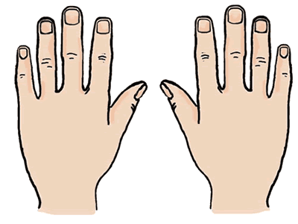
128 4
256
64
8
2

512 1
32
16

As you can see, with all ten fingers down, you’re up to 1023—a lot higher than you used to get when you were a child. With a little practice, counting in binary is easy, and I have never used more than two or three digits on my second hand. Although I often use a tabletop or a similar surface upon which to count, I also often just use the side of my legs. No one notices me as I count, or if they have noticed, they just figure I’m a crazy old man and leave me alone without comment.
The remaining text looks at software products that are either free, or comparatively affordable. Although this course has been developed with the intent that you would develop the skills to build a spreadsheet with the power to handle many of the functions needed for a non-profit ministry, it is quite possible that there would be some things that you are not confident about doing. Pursuant to that, the articles below are offered to provide an idea of what is available to access in terms of software packages for little or no cost.
Please understand clearly that CLI is not endorsing any of these software packages, nor is it implying that other packages, not listed here, are unworthy of your notice. Moreover, these software packages are, for the most part, set up to handle the American legal and financial system. Checking your own national laws and regulations in this area will be necessary if you live outside the United States of America.
In making the decision about what software package will be the best one for you to use, there are a number of points to consider:
- Will the software package run on my system? Some software will only run on a Windows operatingsystems—and sometimes only on specific versions of Windows—others, only on an Apple IOS operating system—and again, perhaps only on certain versions of it. There are other operating systems as well—UNIX, LINUX and UBUNTU come to mind—which may or may not be able to run the program. It is, however, more than just that. The actual computer hardware is also an issue: is there enough random access memory (RAM) in the computer to handle the demands of the program, and is there enough storage on the hard drive or the USB drive being used to store the information. Especially if you will be purchasing software, you need to be sure it will run on your computer. Some software packages actually run on the computer the vendor owns, and your data is potentially stored in “the cloud” or in the vendor’s system. On the one hand, this allows you to use a much simpler, less costly computer on your end, but it does so at the expense of an increased risk of being “hacked” and having your data stolen or lost. Whatever package you use, you definitely need to keep backup copies of all of your data, perhaps on a USB drive or on one of the internet data storage services, such as DROPBOX or GOOGLE DRIVE, as well as storing it on the hard drive of your computer.
- What do I need my software to do for me? If all that you need is to keep track of your income and expenses, possibly breaking the income and expenses into specific categories, then this course should have taught you the skills you need to create a spreadsheet that will take care of your needs fairly easily. It is, however, altogether possible that you may need to have the software to produce specialized reports, including profit and loss statements, annual receipts for donors to use for tax purposes, government required reports specifically aimed at non-profit organizations.
- Am I comfortable using the software? If the software package you are using is one that requires you to do activities you find difficult, or distasteful, to do, or if it requires a large number of entries to do what you need done, there is an increased risk that you will make an error, or, equally regrettable, fail to keep your entries up to date. Many programs that can be purchased will allow you a period of time to try the program out, to see if it fits your needs and your personal style.
- Can my data be easily exported, or easily shared with others? For most ministries, it is advisable to have an accountant reconcile your records periodically—annually is frequently advised—not only to be sure that the records are accurate, but also to be sure that any required reports, etc. are made. In many ministries, there may also be others who should be able to enter transactions or otherwise update the records. Not all software packages make that easy. Furthermore, it is possible that some individuals should be allowed to make entries, but not allowed access to the full records. Does the program have the ability to handle that?
There are, perhaps, other considerations that you see, ones that may be important to you; listing them in advance, before deciding to invest the time, and perhaps the money, to use a particular program is worth your while. In a demonstration of a piece of software, it is all too easy to forget what your concerns are, if they are not written down and in front of you.

Free Accounting Software for Nonprofits
By Dominique W. Brooks
MD, MBA
Nonprofit organizations are often on tight budgets. Every dollar spent must be thought out and accounted for. Not every nonprofit can afford to hire a professional accountant, and many nonprofits rely on in-house accounting methods. If you don't have the funds to hire a professional, free accounting software can help guide your organization in the right direction.

Free Accounting Software Options
When considering a free accounting program, keep in mind what tasks you need the program to perform and if there are any specific reports you are interested in producing. Every program has something different to offer so choose the one that will best match your needs.

GNUCash
This free software can be useful for small nonprofit organizations. It is an open source program that has some characteristics of Quicken and some small business accounting features. This software will allow you to create a multitude of reports, but you may need to export some data in Excel to complete them. You can use this software on Windows, Mac, or Linux systems.

TurboCASH
This free OpenSource accounting software is multi-lingual (25 languages) and allows you to set up your files according to your country. This can only be used on Windows systems.

Adminsoft Accounts
This software is a full double-entry accounting system and even allows you to manage payroll if needed. It will run on any system running a Windows platform and on Mac or Linux machines in certain situations.

BS1 Free Accounting
This software works for small businesses and allows you to establish your files in different currency formats, which would allow you to manage international billing or purchasing. You can also create user-defined financial statements. You can upgrade for a fee to get your software customized if you would like.

SVERDYSH
This is a free British accounting program for small businesses. Instead of giving you a large guidebook, the program gives you examples to show you how to use the various functions.

Open Office
This is another free open source suite of programs that contains tools like spreadsheets and databases to help you with basic accounting functions. It looks similar to other programs out there, so it is easy to operate. Open Office is also scalable to as many users as you may need.

Lazy8 Ledger
This free program is a double-entry accounting program. Your organization can also follow receipts and payments automatically. This program can also run on Windows, Linux, and Mac systems.

Ledger
This free accounting software by Responsive Software runs on Windows systems. It is a double-entry ledger system that can be scaled upward as your organization grows. One of the benefits for non-profit organizations is that you can also calculate account balances when you want and not only on a quarterly or yearly calendar.

FrontAccounting ERP
This is an open source solution for small businesses. This program lets you keep up with bank accounts, general ledgers, and different reports. You can have multiple user access and can use this program on Windows, Linux, and Mac.

Choosing the Best for Your Needs
There are endless versions available that can assist your organization with anything from cutting checks to preparing financial reports. Try out various programs until you find the one that works the best for your organization's resource management needs.

8 Free and Low Cost Accounting Software Options for Nonprofits
Bookkeeping on a Budget for Nonprofit Organizations

By Shelley Elmblad
Financial Software Expert
As a non-profit organization, your accounting software needs to be able to accurately handle contributions from donors, grants, investments and fund raising events, and produce reports that make submitting IRS Form 990 and other tax reporting easier. Small non-profit organizations don't have the cash to spend on expensive specialized accounting software, so I've rounded up some low cost options.
Volunteers without significant accounting experience should not set up accounts in software without help from a CPA or nonprofit financial specialist. The Northland Foundation has a good example of a chart of accounts that can be used to set up accounting software for nonprofit organizations.
This list is definitely not exhaustive. I've not included software that required contact with a sales person for price quote or higher-priced accounting software.

1. ACCOUNTS
ACCOUNTS is Windows software designed specifically for small nonprofit organizations in the U.S. and Canada with a smaller set of features to keep things simple. The software offers basic bookkeeping and easy, automated fund accounting that does not require journal entries to keep an accurate balance. ACCOUNTS has a very generous 60 day free trial and support resources in the software itself, online, and via email or phone.
If you're currently using QuickBooks, Quicken or Simply Accounting / Sage 50 Canadian Edition, your chart of accounts can be imported (but transactions can't). New nonprofits can create their own chart of accounts or choose from one of many samples, which have links to for T3010, 990 or 990 EZ. The single user version of ACCOUNTS can be used on multiple computers, but the database will have to be copied between computers. The network version supports up to five users on a local area network or using the Internet, with simultaneous access to the database.
- Track income and expenses
- Track fund balances
- 15 different reports can be exported to PDF, Excel and CSV
- Annual budget
- Accounts Payable
- Check printing
- Support for multiple organizations on one computer
- Import deposits from DONATION software
- Simple data backup with reminders, back up to USB drive or other media, or sendencrypted backup to an online backup service
Cost: $120 for one user or $200 up to five users per year.
Free trial: 60 days
Platform: Windows
Support: Ongoing
Support: 1 year
Learn more: software4nonprofits.com

2. Aplos
Aplos is online accounting software specifically designed for churches and non-profits, and it is customizable so it can be set up to meet your organization's financial needs. They have been in business since 2008, and are a great option for small nonprofit organization accounting. The subscription includes all the features you need for nonprofit accounting and you can add on additional items like Contributions Management.
Aplos supports as many users as an organization requires, and it takes less than an hour to learn how to navigate and use. Aplos also offers several advantages over desktop software, like data back up, the ability to access it from any computer, and no updates or upgrades to install.
The Base Accounting software includes:
- True Fund Accounting functionality
- Account Maintenance for managing your accounts
- Check Register for transaction entries
- Journal entries
- Custom reports
- Budgeting
- Accounts Payable
- Accounts Receivable
- Branded web pages to accept online donations
The Contributions Management module includes:
- Easy data entry for charitable contributions
- Automated accounting entries for contributions
- Track contributions by person
- Contribution statement print outs
- Donors are automatically entered into People Database.
Cost: Aplos Accounting is $15/month for one user and $25/month for 2+ users. To add Contributions Management it is $15/month more. New church or non-profit plants can also receive 6 months free use.
Free trial: 15 days
Platform: Online
Support: Ongoing
Support: Ongoing
Learn more: AplosSoftware.com

3. Zoho Books with Non-Profit Modules
Zoho is an online office suite with easy-to-use tools that all work together. The business applications include accounting software Zoho Books, a CRM app which can be used for tracking donors and that integrates with email, a human resources module that's free for up to 10 employees, among others. Some perks that Zoho Books authors for nonprofits are multiple currency support, support for bank and credit card accounts, data sharing with an accountant and the ability to receive online payments. Zoho Books can be used by two users with additional user support for $5 a month.
Free or low cost modules that are specific to nonprofits are available from Zoho Marketplace and include:
- Donor Management
- Club Registration
- Volunteer Registration
- Grant Tracking
- Community Bulletin Board
Cost: $24 per month or $240 per year
Free trial: 30 days
Platform: Online
Support: Ongoing
Support: 1 year
Learn more: zoho.com/books

4. Big E-Z
Big E-Z is not stand alone accounting software it is a spreadsheet template designed to be used with Microsoft Excel. It doesn't require double entry accounting and is updated every year to include the latest IRS tax regulations. The template files consist of 12 monthly files with customizable income and expense columns.
Big E-Z is a possible accounting solution for very small non-profit organizations with a bookkeeper who is familiar with Excel. Big E-Z can only be used on one computer. While the template does not require any Excel programming, having an understanding of how Excel works will make using Big E-Z truly easy. The template package can be downloaded immediately after purchase online.
- 10 monthly and 14 year-to-date summary reports
- Help buttons guide user
- Tracks 12 income and 24 expense categories, and tracks up to 100 subcategories
- Checkbook reconciliation
- Mileage tracking
- Budgeting
- Multiple Entity version for up to 4 accounts (people, partnerships, organizations or businesses)
Cost: $59.95-$99.95
Free trial: 7 days
Platform: Windows
Support: 1 year
Learn more: BigEZ.com

5. Araize FastFund Accounting Standard
This software was designed by CPAs to specifically meet fund accounting and FASB reporting for nonprofit organizations, which is a great advantage. The disadvantage is that the cost of the standard software only includes 30 days of phone support. FastFund also has fund raising software and payroll software, but these will set you back another $300 each. From what I could determine only the payroll software integrates with the accounting software.
- Fund balancing audit reports
- FASB 117 compliant reports
- Nonprofit terminology on reports
- Program budgets
Cost: $299
Free trial: 30 days
Platform: Windows
Support: 30 days
Support: 1 year
Learn more: FastFund Accounting Standard

6. QuickBooks Nonprofit
The majority of nonprofits use the very popular QuickBooks accounting software. While this software may be too expensive for most small nonprofits (see if you can find it on TechSoup.org), it needs to be included on this list. QuickBooks Nonprofit has all the features of QuickBooks Pro with tools specifically for nonprofit organizations. Advanced reports include program budget tracking donations and expenses. QuickBooks also has a variety of add-ons (additional fees apply) for payroll credit card processing, bill pay services, check printing and more - so the conveniences are there, but they can really add up.
- Track donations and pledges
- Tutorials specific to the Nonprofit edition
- Easy to learn how to use
- Good customer support
- Fund raising and pledge support
Cost: Retails for $400, but you can find lower prices online for QuickenBooks NonProfit.
Free trial: None, 60 day money back guarantee
Platform: Windows
Support: Ongoing
Support: 1 year
Learn more: QuickBooks Nonprofit Website

7. QuickBooks Online Essentials
A less expensive and more convenient QuickBooks option is QuickBooks online, although there is no nonprofit module so an accountant would definitely have to help with setting up the software. Another option is using the book, Running QuickBooks in Nonprofits, shows organizations how to work with the software as it is. QuickBooks Online Essentials supports three users, has iPhone, BlackBerry and Android apps, and automated online banking. A payroll module can be added.
Cost: $25, or $51.16 with payroll
Free trial: 30 days
Platform: Online
Support: Ongoing
Support: 1 year
Learn more: QuickBooks Online Essentials

8. GnuCash
GnuCash is double entry accounting software that's great for small business, but that can only work for very small nonprofit organizations that don't mind importing some numbers into Excel to get the proper reports due to the lack of any nonprofit plug-ins or add-ons. GnuCash makes it to this list because it's free, supports multiple currencies and has been translated into several languages.
- Actively developed
- Good set of financial reports
- Statement of reconciliation
- Support for investments
- Job tracking could be used for fund-raising purposes
- Budgeting
- Check printing
- Mortgage and loan support
Cost: free
Free trial: n/a
Platform: Windows, Mac and Linux
Support: Online user manual, tutorials, and concepts guide
Support: 1 year
Learn more: GnuCash.org

Accounting 101
Posted: June 3, 2009
Author: Hillary Coley, CPA
Trout Unlimited
Accounting allows organizations to identify how much money is coming in and being spent. Without accounting there is no way to accurately predict cash flows, raise money for projects, or know if you can afford to purchase equipment or hire new staff. Good accounting also allows for grant applications to be more accurate in requesting funding for projects. Without good accounting, an organization has little hope of effectively expanding and maintaining that expansion.
The end product of accounting allows the user to generate reports to show the organization's monetary transactions and net worth. The two most helpful summary reports are the balance sheet and income statement.
Balance Sheet
A balance sheet shows an organization's assets, liabilities, and net assets. The basic layout of the balance sheet is based on the following formula:
ASSETS = LIABILITIES + NET ASSETS
Below are categories of common assets, liabilities, and net assets. See also Statements of Financial Position and Statements of Financial Activity.

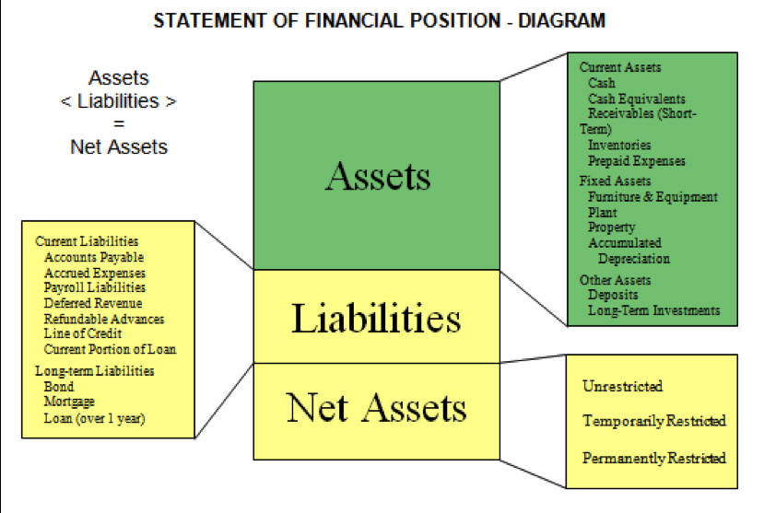
Below are samples of balance sheets.
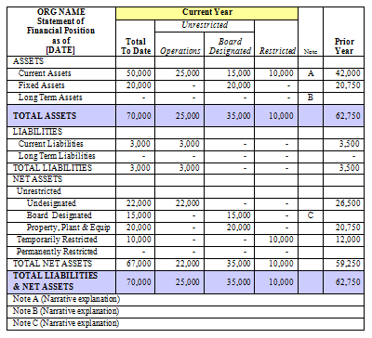
Income Statement
An income statement shows an organization's revenue, expenses, and net income. The revenue and expense categories are determined by you when you build your chart of accounts.
Downloaded from http://www.nonprofitaccountingbasics

