Unit 3

The Concept of a Variable in Mathematics

One of the basic tools in mathematics, beyond simple arithmetic, is the concept of a variable. On the whole, variables are represented by letters: A, B, C or x, y, z, or (for the somewhat more abstruse) letters from the Greek and occasionally the Hebrew alphabet. There have been endless explanations of how to view a variable, but to me, two stand out.

You can look at a variable as being a box with something in it, and you need to figure out what it contains. For instance, you might see something like:

3x + 4 = 2x + 6

You want to figure out what is in that box we call x. If you remember any algebra at all, you can see that the answer is -2. I'll show you how to get that later. The important thing to remember here is that x is just a label we're using for whatever the answer might be.

As an alternative view, assume that 3x + 4 = 2x + 6 is a sentence. The numbers 4 and 6 are acting like nouns; the numbers 2 and 3 are acting like adjectives, the addition sign is acting like a verb and the equals sign is a conjunction. Our variable, x, is a pronoun, and as such, it refers to some noun. The trick is to figure out what noun (which in this context is a number, of course) the pronoun (which is the variable) refers to.

Numbers next to a variable, like 3x or 15z or 42q, just tell you what the variable is multiplied by. You can add these just like anything else: 3x + 9x is 12x. You can subtract them like that as well: 15x -6x is 9x. Multiplying and dividing will come out the same: 2*5x is10x, and 15x/3 is 5x. There are other interesting things we can do along this line, but for our purposes, they won't be necessary.

What is nice about the second view of what a variable is, is that it makes sense of relationships between variables. Consider this sentence: I am with you. It tells me that there is a relationship between you and I, no matter who we are. The same thing can happen with variables:

4x + 2y = 8

You may not have a clue what x and y are, but you know how they relate to each other, and as soon as you know what x is, you know what y has to be. It's much like the sentence "I am your father." Knowing who the pronoun "I" happens to be limits who "your" could indicate. If "I" happens to be Darth Vader, the possessive pronoun "your" would refer to Luke Skywalker, or maybe Leia Organa. If it happens to be me, it would be one of my two sons. Changing the referent for the pronoun "I" changes the referent for the possessive pronoun "your." On the other hand, knowing who "your" refers to can tell you who "I" refers to. It goes both ways with variables as well as with pronouns.

Let's return to the mathematical sentence 3x + 4 = 2x + 6 for a moment. How did I arrive at the answer that x was -2? Technically, that is called solving for x. The process is not mysterious at all, once you see it. You do the same thing to both sides of the equals sign until you manage to solve the problem. In this case, we've got x on both sides of the equals sign, but we want x on just the left side. The easiest way to do that is to subtract 2x from both sides:

3x + 6 = 2x + 4
-2x -2x___
x + 6 = +4

Well, that's better, but we still don't have a clear answer. We need to get x all by itself on the left, so let's subtract 6 from both sides of the equals sign:

x + 6 = 4
- 6 - 6
x = - 2

Let's try that with another mathematical equation—that's what "sentences" in mathematics are called. Let's say:

8x – 13 = 4x + 7

The first step is to get x all on one side; we can subtract 4x from both sides, like this:

8x – 13 = 4x + 7
-4x -4x .
4x – 13 = 7

That's better, but not home free. Let's get x all by itself, now, by adding 13 to each side, like this:

4x – 13 = 7
+ 13 + 13
4x = 20

Again it is better, but still not a clear answer. Next we divide everything by 4, and get:

4x /4 = 20 /4

giving us:

x = 5.

Just to see that this is the right answer, replace x by 5 in the original relationship:

8*5 – 13 = 4*5 + 7

which, multiplying things out, gives us:

40 – 13 = 20 + 7

and adding things up on both sides of the equals sign, we have

27 = 27

which is, of course, true.

Of course, just as sentences can have more than one pronoun, so equations, the mathematical version of a sentence, can have more than one variable. Let's go back to 4x + 2y = 8 for a moment and see what we can learn. As with our first effort, we just do the same thing to both sides of the equals sign, trying to get x on one side and y on the other. To get x all by itself on the left side, we have to subtract 2y from both sides, getting:

4x + 2y = 8

with 2y subtracted from both sides becomes
4x = 8 – 2y

That's better, but let's divide both sides by 4, to get:

x = 2 – ½ y

So, whatever y is, divide it by two and subtract it from 2 and you know what x is.

What if I wanted to solve this so I could get y knowing x? Start with the original equation.

4x + 2y = 8

Since I want y on the left here, I'll subtract 4x from both sides, and get this:

2y = 8 – 4x

There is still room for clarification. Let's divide everything by 2, and get:

y = 4 – 2x

That's easy enough. Whatever x is, multiply by 2, subtract the result from 4 and you know what y is.

Try using different values of y into x = 2 – ½ y to get a value for x, then put that value of x into y = 4 – 2x and see if it gives you the same value for y that you started with. If your arithmetic is correct, it will. Then, try putting those values into 4x +2y = 8 and see if the answer comes out right. Again, if your arithmetic is correct, it will, every time.

At this point, the process may still feel a little strange, but with a bit of practice it will become familiar, even easy.

Continuing in the analogy between a sentence and a mathematical equation, let’s consider parentheses: ( and ). The parentheses mark the opening and closing of the mathematical equivalent of a clause. (x+4)*5 means 5*x plus 5*4, or 5x+20. You can use these “clauses” to multiply each other, as well. Consider (x+4)*(y-7). Here’s how it will break down:

(x+4)*(y-7) = x*(y-7)+4*(y-7) = xy -7x +4y-28

You can, if you want, regroup that and insert the parentheses a different way: y*(x+4)-7(x+4) = (y-7)*(x+4).

One more point: just like numbers can be used to multiply a variable, variables can multiply other variables. So, you can have a*x or b*x or the like. If you want to add a*x to b*x, you have (a + b)*x, the parentheses telling you to figure out the value inside them before you multiply x by them. To subtract b*x from a*x, it looks similar: (a - b)*x.

Exponents in Mathematics

Variables are, as noted earlier, are like containers and pronouns. We looked at handling adding and subtracting variables and multiplying or dividing variables by a number. What if we start multiplying a variable by itself? How does that work?

This is where exponents come in. The exponent, which is a number written above and to the right of a variable, tells us how many times a variable is multiplied times itself. This is often referred as the variable being raised to the power of the number.

x*x = x²

x*x*x = x³

x*x*x*x = x⁴

And so on. Technically, we could write x¹ for just x; on the whole, no one bothers for convenience sake. As a further point to remember, x⁰, which x to the exponent zero, is defined as being 1.

How do we handle it if we have a variable to some power multiplied or divided by itself to another power? The answer is that we add or subtract the exponents, depending on whether we are multiplying or dividing. So, we have:

x⁵ * x⁴ = x⁹

x² * x = x³

and for division,

x¹⁰ / x⁵ = x⁵

x³ / x² = x

x⁴ / x⁶ = x⁻²

Hey, wait a minute—what just happened here? We have x to a negative power! What on earth does that mean? If you think about it a second, it means you're dividing by x to that power. So, you have:

x⁻² = 1 / x²

x⁻¹ = 1 / x

x⁻⁵ = 1 / x⁵

And so forth. What makes this interesting is that you still are adding exponents, here. That means that:

x¹⁰ / x⁵ = x¹⁰ * x⁻⁵ = x⁵

x³ / x² = x³ * x⁻² = x

x⁴ / x⁶ = x⁴ * x⁻⁶ = x⁻² = 1 / x²

And of course,

x⁴ / x⁴ = x⁴ * x⁻⁴ = x⁰ = 1

In later units, we will be looking at things involving interest calculations, and the concept of the exponent, raising a variable to some power, will become very useful.

There is a great deal more that could be said about exponents but the only important point to add is that you can use a variable as an exponent, as well. X^{n} or Y^{-n} is valid, and in some of the formulas you will see later, you will be seeing that. Also, although it is not as intuitive as raising a variable or number to an integer power, you can raise things to powers that are fractions, or integers plus fractions—but that's for a more advanced course in mathematics.

Budgets
As noted in the introductory lesson, although this course will be teaching mathematics, the knowledge gleaned will be applied to basic financial concepts necessary for ministry and for personal finance. The first step along that line is the concept of a budget, which often strikes fear in our hearts. It shouldn't do that, however. A budget is a tool that is used to help keep us from falling into the traps created by money temptations. The relationship with money is one of the most talked about themes in the Bible.
Budgets need to be seen as the only practical means to get a grip on spending, and on being sure that the money entrusted to you is being used as God intends you to use it. This unit will make the assumption that you do not have a budget, and that your information is not online.
Your first step needs to be figuring out where the money goes. Ideally, you have all your receipts, paycheck stubs and other records of expense and income for the last year, or if not, at least for the last month. Take these records and sort them out into categories that make sense to you, then record them on your spreadsheet, ordered by their date. With this in hand, you can get a grip on where your money comes from, and where it goes.
Typical categories of expenses include:
- Housing (rent, mortgage, etc)
- Utilities (electricity, natural gas, telephone, water, etc)
- Food (Groceries bought, restaurants visited, vending machine purchases, etc)
- Transportation (Payments on the vehicle loan, fuel, repairs, oil changes, tires, etc)
- Insurance (Life, health, homeowners, automobile or motorcycle, etc)
- Clothing
- Entertainment (Movies, books, vacations, hobbies, cable, etc)
- Tithes & Offerings (Giving to church, to para-church organizations, etc)
- Savings
- Education
You may have several other categories that are important, and there is always that category "Other" or "Miscellaneous" to put on the spreadsheet for those things you have no idea where to put.
With this all laid out, look at where your money goes and ask yourself where you could, or should, cut back on spending. Particularly, look at whether what you spend in a given month is more or less than what you take in during that period. If you do not spend less than what you earn, you have to cut back until you do spend less than you earn, whether you are looking at your ministry budget, church budget or personal budget!
After looking all this data over, decide what you will spend in each category every month. Write it down. Be realistic with what you decide and be sure you are not planning to spend money you will not or do not have. Once that is done, live within that budget.
Several things are worth watching for:
- Cash leakage: Some costs will creep up slowly. Utilities can slowly rise (not turning the lights off when you leave a room, leaving device chargers plugged in when they are not in use, not fixing leaking faucets, for instance), or the money spent on food (it is easy to get into a habit of buying little treats, isn't it?) and others. Some will represent cash leakage that can be prevented, some will not, and will require something else in the budget to change.
- Spending beyond your limits: Once you decide how much you plan to spend for each category on a monthly basis, stick to that decision unless you are confronted with a bona fide emergency. Always try to spend less than your chosen limit, and save the rest
- Beware of luxuries pretending to be necessities. Yes, that car is five years old, but it still runs: do you really need a new car? You may have last year's model of your smart phone, but it's still doing the job, so stick with it for a little longer. The outfit may not be the latest style, but it's not threadbare, badly faded, torn or stained. Replacing it is another luxury pretending to be a necessity.
- Tithe yourself as well as God. God has first call on all that we have, and what we give Him should come out of our money first. We need to put money aside for ourselves, as well, to save for emergencies that may come up—some needed thing that breaks and has to be replaced, or that sudden illness that not only reduces the income but also costs money for medication, repairs on our transportation or home, or some other such urgency—so there are resources to address those emergencies. Financial advisors strongly suggest working towards having enough money saved to handle your budget for three full months, and to be able to handle any co-pays on your varied insurance policies. You don't have to do that overnight, but it is a wise target to work toward.
- Don't count on windfalls. God may choose to suddenly bless you with a financial lump sum, but don't plan that He will do it. He might not! Do not tempt the Lord your God.
- Beware of spending creep. This is much like cash leakage. Things can become more costly over time. The rent might go up, or the charge for your internet provider might rise, the list is long. Be aware of those changes, and adjust your budget to handle them
With all of that in mind, and your budget in hand, make a point of keeping track of your expenses and income. Get into the habit of recording it all on your spreadsheet, then returning to look at how things are doing. It is altogether possible, for instance, that you may have constructed a budget that isn't realistic in one area or another, and you may need to rethink it. Equally possible, you may find yourself neglecting some area in your budget—saving and tithing are commonly ones neglected—so that you can put the money elsewhere. That, too, needs dealt with.
Over time, budgets often need adjusted. Prices rise, income changes, and perhaps preferences change. Be diligent in watching your budget, your ministry and yourself so that you can see adjustments that need made before they become a problem.

Budgeting: Needs and Wants
Have you ever thought about what you would most like to buy when you earn money? List the items here
At some stage in your life you will have to make decisions on how to manage your hard-earned income. You will have to balance your spending and income. In your ministry life, this is going to be crucial since you need to know what is coming in to your financial reserves and what is being used from your financial reserves. This is called "budgeting."
Drawing up a budget will help you make decisions.
You will have a list of needs and wants. Make a list of these, grouping them under the two headings "Needs" and "Wants" in the table below. Try to put the most important ones at the top of the lists! See if you can explain to a friend how you arrived at what you think are needs and what are only wants.
Needs  (What I have to have) | Wants  (What I would like to have)

Budgeting: Tracking Income and Expenses
Create a budget for yourself for the next week. Remember to record all the income you will be receiving. Make a list of your expenditures, prioritizing your needs and wants.

Income |  | Expenses
Source | $ | Paid to/for | $
Total: |  | Total:

Does your spending actually balance with your income? If not where will you get the extra money from? Perhaps you will have some money left over, what could you do with it?
Find a person with whom you can discuss some ways you could increase your income. How do you think you would use this money to balance your budget?

Budget - Fixed and Variable Expenses
A good way to make sure you have enough money to spend and save is to use a budget. A budget helps you make sure your income matches your expenses. A budget also helps you with saving money.
Each month, you may receive income from the job you have, and interest from the money you save. Also each month you will have expenses. There are two main types of expenses, fixed expenses and variable expenses. Fixed expenses tend to be about the same each month, for example rent. Variable expenses tend to fluctuate each month, such as clothing.
One good way to create a budget is to track your income and expenses for one month, by keeping track of each type of expense and if that expense is a fixed expense or variable expense. For the month, Mackenzie earned $556 and tracked expenses for the month to help create a monthly budget. Fill out the table below using the expenses Mackenzie tracked. Then total fixed and variable expenses. Also calculate total expenses. Was income greater than or less than expenses for the month?
Expenses: Going to the movies $21, Phone bill $41, Rent for an apartment $156, Tax on earnings $171, Music CDs $26, Eating out at resturants $64,New shirts $28, Car repairs $13
Category | Fixed | Variable
Expenses
Taxes
Rent/Mortgage
Utilities
Groceries/Food
Clothing
Shopping
Entertainment
Miscellaneous/Other
Totals of columns
Total expenses (Fixed + Variable)

Answers
Category | Fixed | Variable
Expenses
Taxes | $171.00
Rent/Mortgage | $156.00
Utilities | $41.00
Groceries/Food |  | $64.00
Clothing |  | $$28.00
Shopping |  | $26.00
Entertainment |  | $21.00
Miscellaneous/Other |  | $13.00
Totals of columns | $368.00 | $152.00
Total expenses (Fixed + Variable) | $520.00

Income - Expenses = $556 - $520 = $36

Budgeting
What is a budget?
A budget is a money plan. It is like a blueprint of how much money you earn and how and where you spend it.
Why should I budget?
Whether you have a lot of money or just a little, a budget can help you in many ways:
If you have a budget and stick to it, you will be less likely to waste your money during random daily spending.
A budget can help you reach a financial goal because it controls how much you spend and how much you save.
Budgets can help eliminate many money surprises because you've
planned ahead and know what to expect each month.
No matter if you are young or older, you can start budgeting now in order to build the habit.
Budgets help you see exactly where your money goes.
How do I budget?
When you are setting up a budget, you first need to decide if you're going to use a weekly or monthly budget. If you get a weekly paycheck, go for a weekly budget.
Start with how much money you get each week. Figure in all the income you generate in jobs that you get paid for doing.
Next, figure out what you need to pay for with this money. Do you need to cover the rent or the house payment? Who pays for food in your household? How does your spouse get to work - do they need bus fare? List these expenses under "needs”.
Finally, figure out what you want to spend your money on. Do you have a specific plan for your ministry? Do you want to do the work of a pastor for free in your ministry instead of being paid? Is there something larger that you'd like to save up for? List these expenses under "wants”.
Add up the totals and see if you have enough money each week to cover these expenses. If not, you'll have to figure out where to cut expenses to get your spending equal to or less than your income.
Weekly Income:
Needs:

Wants:

Where Does the Money Go?
When you're not paying attention to your spending, it can be difficult to understand where the money goes. Try this exercise to help you see how much it really costs for the things you enjoy.
Look at the following list. These are common household expenses and how much they cost per month on average.
Electricity: $100 / month
Groceries: $50 / month per person
Cable: $80 / month Internet: $40 / month Gas: $120 / month
Now, write down one thing that you like to buy with your money:
________________________
How much does one cost?
________________________
Pick two items from the above list. Figure out how many of things you listed it would take to pay for this monthly bill.
For example: Maybe you like to give monetary help to your sister. It costs you $100 every month just to help out a little with her bills. That means it would cost you the same as your electricity bill each month. Can you find the money for that?
Here's another one: Maybe you like to go weekly to a park where the admission is two dollars for each member of your family (Let's say you have five people in your family.) What can you eliminate from your necessities to be able to enjoy the park each week?

Debt: Paying off debt

The basics of debt reduction are simple: Cut down on your variable spending and put the extra money toward your debt payments. But outside of fixed monthly bills such as housing or car payments, you probably don't have a precise idea of how you spend most of your money.

1. Figure out where your money goes. If you want to get your debt under control, start by figuring out your spending patterns and identifying unnecessary expenses. For one month, write down every cent you spend, including that $2 cup of coffee or a $4 magazine. That will clarify how much of your spending is fixed and how much is variable (and hence easier to curb).
2. Cut out the extras. Tally the expenses on the list and compare the sum to your monthly income. If it's less than what you earn, use the extra money as your debt payment. If it exceeds your income, you need to cut back on the variables.
3. Lower your fixed expenses. Reining in discretionary spending for a few months goes a long way toward tackling debt. But if that's not enough, try to reduce your fixed expenses. Take steps to lower your household bills; refinance your mortgage to get a lower interest rate; or, if you have a good payment history, ask your credit card company to lower the interest rate you're charged.
4. Try to boost your income. Consider whether there's any way to boost your take-home pay. If you get a big tax refund every year, that means you're having too much withheld from your paycheck. If that's the case, you can reduce your withholding by changing your W-4 at work.
5. Make a list of your debt. Next, make a list of all your debt obligations and the interest you're charged for each. Put them in order of interest rate, from highest to lowest.
6. Transfer high-interest balances. You might consider moving some of your high-interest credit-card balances to a card with a lower interest rate. But read the fine print on any invitation to transfer balances. Sometimes such low-interest-rate offers are only in effect for short periods of time, after which the rate skyrockets. What's more, consolidating your debt on one card may lower your credit score if your debt-to-available-credit ratio worsens.
7. Pay off the highest rate first. Once you determine the maximum amount you can pay off each month, pay down the debt with the highest interest rate first -- that usually means your credit-card balance -- while paying at least the minimum monthly amount due on all other revolving bills. Some financial advisors suggest, by the way, that you find a smaller debt and start by paying that one off: the feeling of success involved in doing that will provide some psychological impetus by proving that you really can get debts paid off. After successfully handling a few of the smaller debts and building a sense of confidence that it can be done, start tackling the highest interest rate debt aggressively. Having handled a few smaller debts will also potentially provide additional funds to attack the higher interest rate, potentially larger, debt.
8. Move down the list. Once the debt with the highest rate is wiped out, put your money toward paying the debt with the next-highest rate. One exception: If you have a credit card with a low teaser rate that will go up after a fixed amount of time, strive to eliminate that balance before the low rate expires.

Uh Oh, I've been Scammed
Hi Everyone, the following article was condensed from
https://www.moneyadviceservice.org.uk/en/articles/beginners-guide-to-scams
Scams have become a multibillion dollar industry, using increasingly sophisticated tools to get money sent or to gain access to the information that will allow them to remove money from your accounts. All of us can be potential prey to scams, no matter how intelligent we may be. In fact, studies suggest that the more intelligent and more educated may be easier victims for many scams.
A beginner's guide to scams
Knowing about the common scams that fraudsters are trying to use to steal your money can stop you being conned. Read these handy pointers to help you spot a scam.
How to spot a scam:
There are some general signs that should set alarm bells ringing wherever you see them. Be very suspicious if:
• Something sounds too good to be true - like free stuff or quick, easy money
• You're asked to give out personal or bank account information
• You aren't given long to make a decision or you feel pressured into making one immediately
• You're contacted unexpectedly by a company or person of whom you have never heard—this can be by post, email, phone, text or on the doorstep
• You're asked to pay anything up-front
• The only contact details are a mobile phone number and a PO box address

Common scams and what to watch out for
- Phishing: Phishing is where someone tries to con you into revealing personal information like your bank account details. A common trick is to send you a fake email pretending to be from your bank or another organization you trust such as HM Revenue & Customs or PayPal, asking you to visit a website and log in with your account details. The site looks just like your bank's website but is really a fake site set up by criminals to get your details. Email is the most common way of doing this, but you might be targeted by text message or by phone. If you're suspicious, ask to call them back and see if the number matches your bank's real phone number. Make sure you get a dial tone before you call, in case the scammer has stayed on the line.
- Pharming: This is when hackers re-direct the traffic from a genuine website to another, such as a fake e-commerce or banking site. This is a very sneaky kind of attack, as although you've entered the correct information to the right site, you're still sent to a fake one to try to get your personal information.
- Advance-fee fraud: This is also known as the '419 fraud' or 'Nigerian bank scam'. You'll receive emails from people claiming to be ex-ministers or royalty from other nations, often in Africa, asking if they can use your bank account to deposit a large sum of money in order to get it out of the country. They will normally offer to pay you a fee. They'll ask for your bank details and may also ask you to send money to cover legal fees and so on. But there is no money and you'll be out of pocket. There is also a similar scam coming from China that's related to wills.
- Dating fraud: Some fraudsters will connect with you on a dating website. They'll be up-front about living overseas and will email you, getting to know you over time and becoming affectionate and romantic. Then once you've become involved they will start asking for money for a sick relative or for a plane ticket to come and visit - and will happily take your money but never appear.
- Money Mules: Here you could unknowingly end up breaking the law and helping criminals by using your bank account to take delivery of, and then forward, stolen money and be paid a commission for helping. You would be breaking the law by money laundering.
- Boiler rooms: Also called 'pump and dump', this is a scam where fake stock market traders contact you out of the blue and give you the hard sell on buying shares that are either non-existent or virtually worthless. You might be offered secret stock tips to make it all seem more believable and sent fake share certificates to try to make the business seem legitimate. Then the fraudsters will disappear with your money.
- Vehicle fraud: There are a number of scams around buying and selling cars. You may be sold a stolen vehicle or a cloned car where the details of the car have been changed to match a legitimate vehicle. You could pay for a car that is never delivered to you or one that doesn't match what you've paid for.
- Online auction fraud: With the growth of online auction sites, there are con artists who will pose as fake buyers who appear to pay for the goods that you then send to them. The problem is that the payment bounces. Or there could be fake sellers who take your money but don't send the goods or send something that's less valuable or very different from the description.
- Job scams: There are a variety of job scams which range from promises of a new career, where you're asked to pay up front for training or materials, to being offered non-existent jobs abroad where you are then asked to pay a fee to organize visas and accommodation.
- You might also get caught by a work at home scheme where you are told you'll make easy money and you may have to pay a fee up front to register. However, the 'leads' or products turn out to be worthless and - worse still - your registration details may be sold on to other scammers.
- Health scams: If you see an email or an advert for a 'miracle cure' for baldness, cancer, impotence, acne or weight loss, then steer clear.
  - You could be offered something that appears to be a legitimate alternative medicine but doesn't actually work
  - Or you might think you are getting drugs and medicines very cheaply or without a prescription but they may not be the real thing - if they actually turn up at all
In some cases these fake medicines can actually damage your health.
- Prize draws, sweepstakes and lottery scams: You could get a letter or email telling you that you have won a lottery, sweepstake or other prize draw and offering you a large prize. The scam can then take different forms:
  - You might be asked to send a small amount of money in order to claim it as a processing fee or legal fee - but no prize exists and you lose the cash
  - You might be asked to prove your identity with a passport - which is then used by the crooks to steal your identity
  - You might be asked to provide your bank account details so they can pay the money in but this information is then used to clear out your account
  - You might be told you have won a prize and you need to ring a special phone number to claim it - the call goes to a premium rate number, takes ages and will cost you more than the value of the prize you've won
- Property fraud: If someone offers you a get rich quick property scheme then there are a variety of ways they could be trying to defraud you.
  - You might be offered a way to buy into a development that is not yet built with all sorts of claims about the profits you'll make - but the land is either farmland or derelict and will never get planning permission or is unsuitable for development so you'll lose your money. This type of fraud is also sometimes called 'landbanking'
  - A fraudster might steal the title deeds to a property and pretend to be the owner and then try to borrow money against the property
- Face-to-face fraud: There are many legitimate door-to-door sales staff - but others don't have good intentions. You can be pressured into buying something you don't want or isn't worth the money you pay for it.
Fraud by bogus tradespeople can take a variety of forms:
  - Fake charity collections
  - Selling you unfair or unsuitable contracts
  - Home maintenance or improvements that you are overcharged for or are badly done
  - Potential thieves who are checking out your valuables once inside your home
- Pension scams: Pension fraudsters will tell you they know a loophole so that you can get hold of some of your pension money before retirement. While you can make arrangements to get cash from it if you're 55 or over, it's likely to be a scam if you see claims that:
  - You can get cash before the age of 55
  - You can get more cash than under your current scheme, or
  - You can have more than 25% of the pension value "released”
They might charge you a fee or land you with a big tax bill.
Next steps
There are numerous ways to be parted from your money. Check out more potential fraud situations so you know what to avoid.
How to avoid being scammed
Given the number of potential scams there are easy ways to make sure you don't become a victim.
Protecting yourself from scams and theft
There are many con artists out there trying to part you from your money. Follow these tips to prevent yourself from becoming a victim of fraud.
How to recognize a scam
These days most people know about dodgy emails that try to get them to hand over their personal details or buy knock-off prescription drugs or watches - and the biggest risk of fraud is still online. But you can also fall prey to the tricksters by phone, by text, by post and in person.
The best advice is that if something seems too good to be true - it usually is.
Top tips for protecting yourself from scams and theft:
Taking some simple steps will make sure you are better protected:
Keep your cards and PIN safe and secure
• Make sure your cards and PIN are safe - don't write your PIN down, and if you have, make sure you don't keep the note and your card together.
• Don't let your card out of your sight when you're paying.
• Don't give your PIN to anyone else.
• Shield your PIN whenever you enter it - both at a cashpoint and whenever you use your card for a purchase.
Make sure your computer is protected, and use it wisely
• Keep your security software and firewall up to date to find viruses, spyware and other 'nasties'.
• Download any patches for your computer's operating system from the official website of the company that created it (like Microsoft), as some fraudsters target possible loopholes. Patches fix known bugs for computer systems.
• Password-protect your computer with a strong and not easily guessable password and make sure your screen's locked when you're not around. For a strong password, use a mix of letters and numbers - this can still be easy to remember if you use numbers to represent letters in a word.
• Bookmark websites like your bank and the shops you buy from regularly and use these links or type in the name directly. Never use links sent to you in emails: they might be bogus, even if they look genuine.
• Don't give your online passwords away. Banks generally won't ask for a full password - just selected letters from it. If someone rings you up and asks you for your full password don't give it to them - it's likely to be a scam.
Be a sensible online shopper
• Check the details of a company you are buying from online. If the only contact details are a mobile number and a PO Box rather than a full address you should be wary.
• Make sure that the website is secure. Only provide card details if the web address starts with https://. Often a golden padlock will show in the browser bar so you know it's safe and secure - although some companies use a different system and their sites will be secure even with no padlock.
• Sign up to Verified by Visa or MasterCard Secure Code if you have the option while shopping online. It provides an extra layer of security for you with shops that have signed up to the schemes.
• Deliberately enter a wrong password - you can check a site is genuine if you enter your user name and put in a wrong password. If the site is genuine it will tell you that your user name and password don't match.
Check the credentials of any financial adviser you use
The Financial Conduct Authority (FCA) requires all firms offering financial products or advice to be registered with them to conduct business. You can use their online firm check service if you're unsure about a firm that has contacted you.
Keep your details safe
• Shred any documents you're getting rid of before binning them if they have any personal details on them.
• Don't forget to shred receipts if they have your card details on them.
• Get a shredder now if you haven't got one - you can pick one up for less than £20. Although do consider a cross-shredder as these are more secure than the 'strip-cut' variety.
• Keep all documents that you still need in a safe place.
Stay alert and be suspicious
• Ask people for ID if they approach you or knock on your door.
• Think twice if either you get an unsolicited offer, you've been told you have won a prize in a competition you haven't entered, or you're being pressured to decide on buying something quickly.
• Check and double check before handing over any money or personal details.
• Check your bank statement when it arrives and query anything that seems odd.
What to do if you think someone is trying to scam you
If you receive an email you suspect to be from a scammer - don't open or reply to it, don't click on anything in it, or you'll just end up receiving more. If the email you are suspicious about is pretending to be from for example your bank, it's worth contacting the bank and telling them about it. They may then be able to warn other customers. If you have the option to report the email to your email provider, use it.
• Don't reply to suspicious letters received in the post. Signing up to the Mailing Preference Service should help stop any further unsolicited mail. It's free, and you can do it at mpsonline.
• Similarly, signing up to the Telephone Preference Service makes it illegal for companies or organizations who want your business to call without your permission. Sign up for tpsonline.
• You can report the scams to Citizens Advice consumer service and you should report banking scams to Bank Safe Online.
• If you're called by a scammer then hang up the phone, and don't give out any personal details.
• If someone asks you to keep the deal or the offer secret then you should be suspicious of them and decline the offer.
• If you suspect someone isn't from the company they say they work for, then ask to see their ID (in the case of a face-to-face scam).

Managing the Church Finances Part 1
Managing The Church's Financial Resources
How is your church managing its money? Is everything in order? Is the senior pastor unjustly benefiting? What would happen if someone inspected under a microscope what your church is doing?
By John P. Joseph
If there has ever been a time for pastors to have their churches' finances in order, it is today. Whether warranted or not, the media is searching for CEO mismanagement. Newspapers swirl with stories of mismanagement from Enron to WorldCom. Some of this searching is justified, but there is a deeper message: Corporate leaders in for-profit and not-for-profit organizations are being scrutinized for leadership and fiduciary responsibilities. They are being held accountable by their shareholders, and in the case of religious organizations, their members.
How is your church managing its money? Is everything in order? Is the senior pastor unjustly benefiting? What would happen if someone inspected under a microscope what your church is doing?
As a church business administrator, I have consulted with many churches. While visiting churches or speaking with pastors, the most common questions I am asked have centered on managing church finances.
In 1 Corinthians 14:40, Paul wrote, "Let all things be done decently and in order." Church leaders sometimes feel inadequate to fulfill Paul's admonition, especially in the area of managing church finances.
We will discuss this broad area by taking a journey. Our starting point will be choosing a financial institution. We will then discuss offerings, making the deposit, payroll requirements, ministerial tax issues, and creating a budget. We will also address spending money, creating financial reports, and storing important financial records.
FINDING THE RIGHT BANK
Finding a bank is easy. The hard part is finding the right bank. Not all banks are the same. While banks may offer similar services, they are often different in fees and structure.
There are three types of banks: the large money-center banks, regional banks, and small-community banks. Large money-center and regional banks are generally considered impersonal, whereas the community bank is not. But beware of small-community banks for reasons of confidentiality. Bank officers may serve as leaders in other churches, and your financial issues may not be held in confidence. I recommend using a local bank provided it is FDIC insured, and you feel comfortable with the privacy issues.
Search for a bank that offers free commercial checking, but find out its requirements. Watch out for minimum balances. Are such balances based on minimum or average balances? Will the bank charge the church for returned checks in the church deposits or waive such fees? Furthermore, find out if it has a per-check charge for depositing with a teller. A church may be able to avoid this by using the bank's night drop box. However, some banks may charge for depositing checks anyway. Suggestion: Deposit offerings into a savings account, and by computer or telephone, transfer the money into your checking account to avoid the per-check deposit fees.
Once you have chosen a bank and opened your operating account, immediately open a savings account. We will address saving money when we look at budgets.
Remember, banks want a lending relationship. After opening the church's checking account, consider applying for a loan to establish credit history. This may be for purchasing a van or a line of credit to help with liquidity issues. Establishing credit does not mean a church needs to be in debt. Credit lines will be discussed later in this article.
RECEIVING AND MANAGING OFFERINGS
Once the bank account is established, the church is ready to receive offerings. Make it easy for people to give. Use offering envelopes with the following information: contributor's name and address, tithe amount, offering amount, and a space for special offerings. Assigning a giving number for each contributor will help staff impute contributions.
Consider vendors who mail preprinted envelopes to your attendees. Some offer them with a self-enclosed stamped envelope. This makes it easy for people to give. They simply place their check in the envelope, which already has their personal information, and drop it in the offering plate or mailbox. One such vendor is Church Budget Envelope Company at 1-561-369-7767.
Suggestion: Place an offering box in the foyer. People sometimes give pastors their tithe checks if they miss the offering. With an offering box, attendees can securely drop off their offering at any time. The offering box should be locked and have ushers empty it after every service. You will see an increase in giving.
When handling money, always consider protective measures or what is commonly called internal controls. These barriers prevent theft and any accusations concerning mismanagement of funds. Generally, pastors need to avoid handling money, and employees or volunteers assigned to this task should do so in the presence of others.
Collecting offerings
Ushers who are not deacons or officers of the church should receive the offering to avoid all appearance of impropriety. Deacons often review financial statements. At least two ushers should walk the money to the drop box or counting room. This room should be unmarked. If the offering is not going to be counted immediately, it should be placed in a locked cabinet or preferably a drop safe in the presence of at least two individuals. Do not have ushers count the money. Rather, have counters who are not rushed in counting the offering. Also, ushering is generally one of the first ministries people become involved in. It is not uncommon for people to be chosen at the last minute to help collect the offering. More diligence needs to go into selecting the counters. This is another layer of protection.
Counting offerings
It is common in some churches for the pastors and church secretaries to count the offering. This is not advisable. Instead, have other trusted individuals handle the money. This prevents false accusations and protects the pastor.
Have at least two (preferably three) individuals count the offerings to avoid corroboration. Select a locked room and do not advertise when and where these people are counting the offering. Periodically, have a staff member walk in unannounced.
The counters should count the offering during or after each service and create a separate deposit slip for each service. The counters need to confirm that the amount contributed on the check is the same as what is written on the giving envelope. For checks that were not placed in an envelope, the counters will need to fill out an envelope.
A cash receipts count summary is then completed. This is one way to keep track of service totals and help a church access the financial growth or decline of its services. Additionally, it makes it easier if a contributor has a question about his or her offering on a particular day. Simply ask what service he or she attended and pull the offering envelopes and deposit slip for that service. The offering envelopes are stored by service and easily accessible. We will discuss how long to keep these records later.
Depositing and imputing offerings
After the offerings have been counted, the counters need to verify that the deposit receipt matches the figures on the cash summary. They then need to place all offerings in a lockable bank bag and have at least two individuals take it to the bank for deposit.
There are two common ways to input contributions--by a person's last name or by a giving number assigned to a family or giving unit. Both are appropriate, but most churches prefer the numbering system since it is easier for the contributor and creates fewer accounts.
Unit 3 Excel

In Unit 2, we looked at the basics of building a spreadsheet to track cash flow, recording information about income and expenses. What we ended up with looked like this:
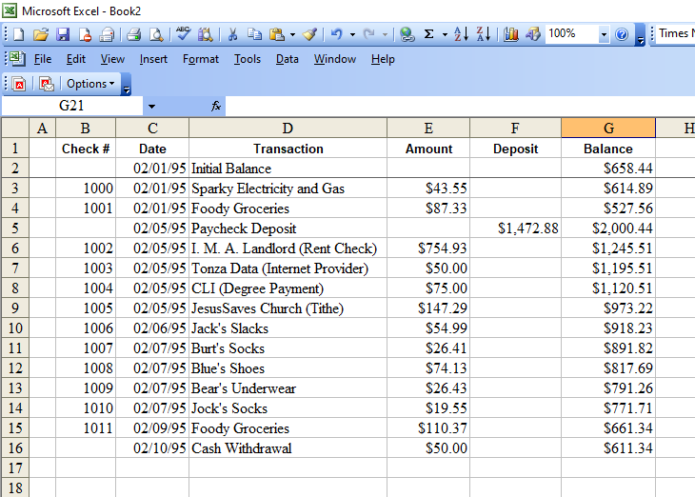
That’s nice for keeping track of how much money there is in your checking account or on your debit card or whatever, but it doesn’t really tell you where the money went, or how much money has come in. It would be nice to have the spreadsheet do that for you, too, wouldn’t it?

Let’s start by working with a few additional columns, titling them for the categories suggested in the text of the lesson for unit 3. I’ll also add a column for deposits, too. We’ll end up with something that looks like this.
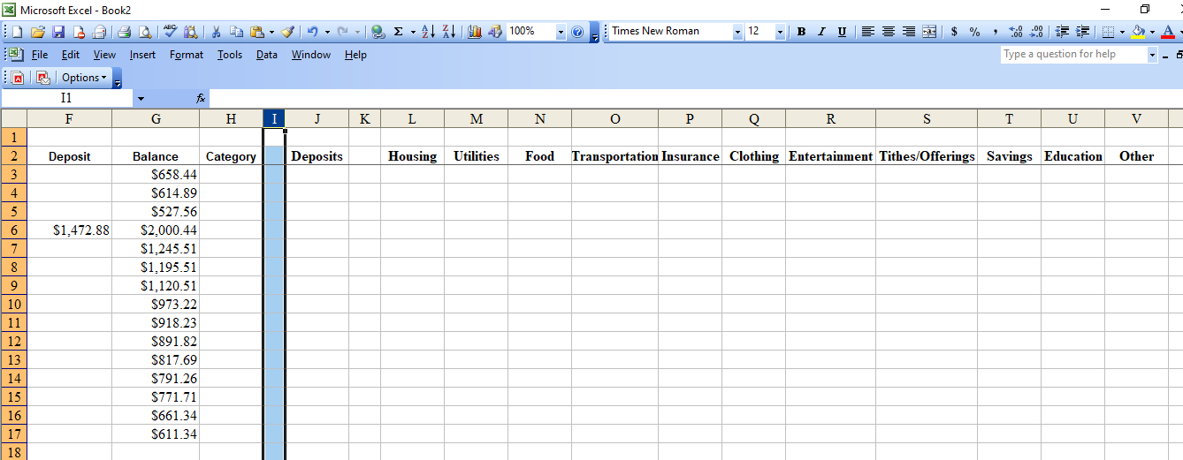

Since the interest is in the right-most columns, I’ve only displayed those. You will also notice that I have adjusted the columns to fit the names at the top. Let’s fill in some of the categories in column H. Be aware: you need the entries in column H to exactly match the titles of the columns to the right.
Also, those columns are sometimes pretty wide to get the whole name in. Highlight the cells with column names in them, then click on Format. You should see something like this.
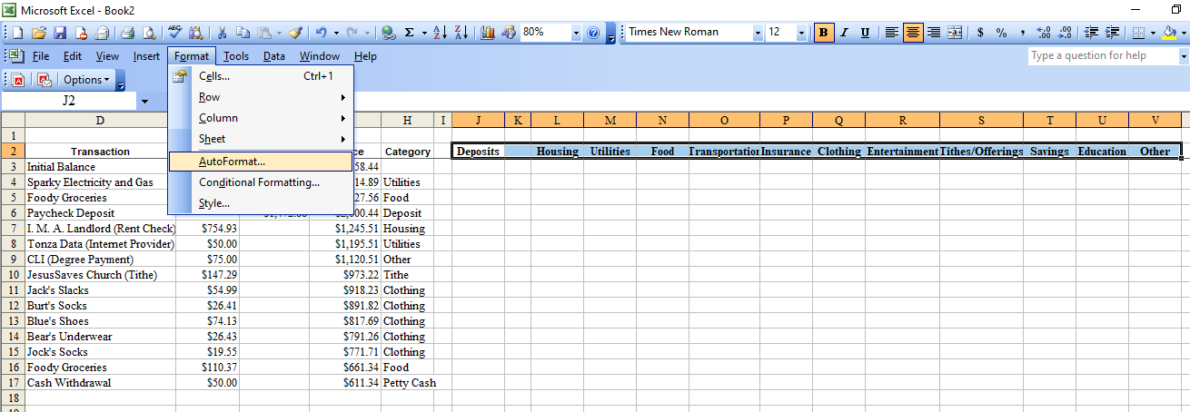
Click on Cells, and see this:
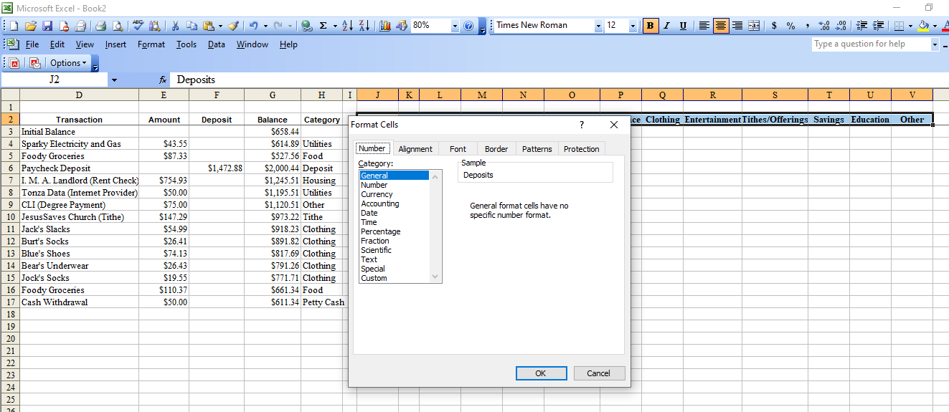
You’ll see Alignment as a tab. Click on that, and you’ll see:
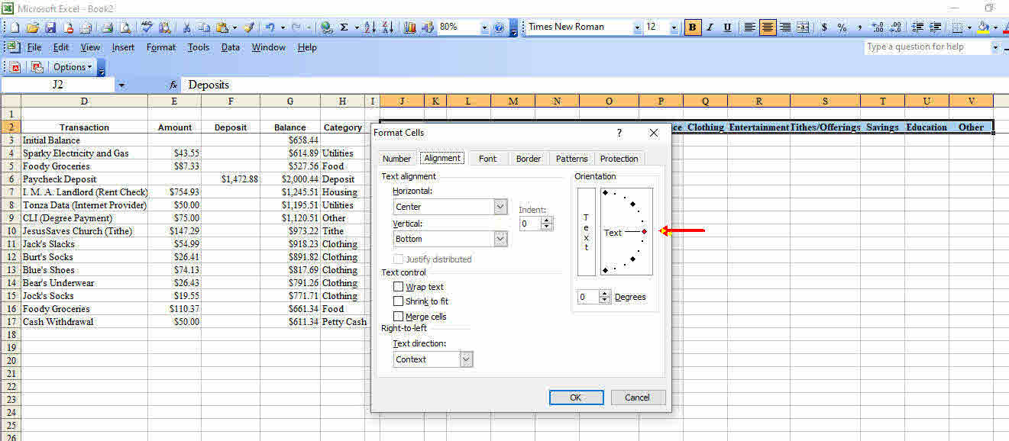
Now, that red arrow points to a dot directly across from the word Text and a line. Click and hold that dot, and sweep it upward, all the way, or almost all the way, to the top and let it go, then hit OK.
Your screen should now look something like this:
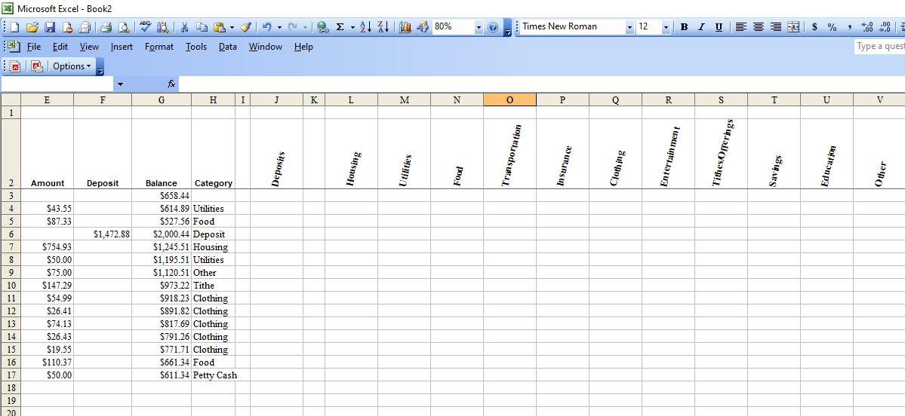
You can see that I set columns J through V to about the same width as column E. What we want to do in every column is look to see if the entry in column H matches the contents of the cell at the top of the column, and if it does, put the amount of the entry in column E in that column (Column F if it is a deposit)—otherwise we want to leave it blank. Also, as the contents of the first cell in the column is copied downward, you want the number to stay the same. When we copy things off to the right, rather than down, we’ll want to have the column automatically adjust. The signal to not change the letter or not change the number is the dollar sign, $. To keep the column staying at E, but letting the number of the row vary, use $E4 or whatever row you are using. To keep the row the same, but let the column letter vary, use E$4, or whatever cell you need. To keep both the row and column the same when you copy a cell to other places, use $E$4.
That may sound a little confusing, but let’s start by having the spreadsheet look for all the deposits. I’ve set things up
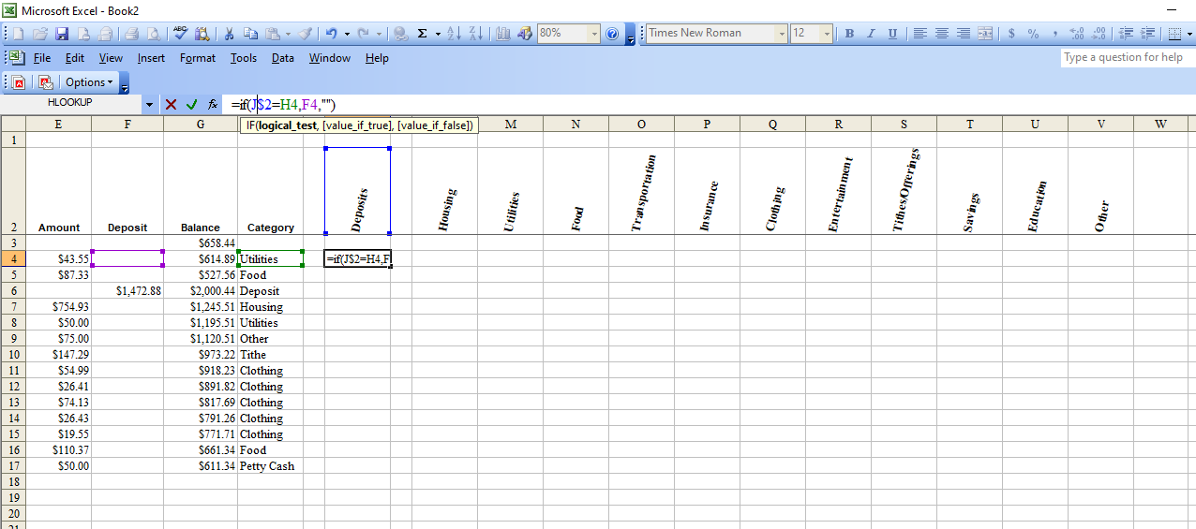
Notice what is in the fx box. =IF(J$2=H4,F4,"") That’s the formula we want to copy downward. The $ before the 2 means that the 2 will not change as you copy the formula. The J will change if I copy this across other columns, unless I put $ in front. Also notice that EXCEL has marked the three cells we’re referencing with a colored outline. This all looks right to me, so I’m going to copy and paste this to fill in a lot of the column. Here’s the result of what I’ve done:
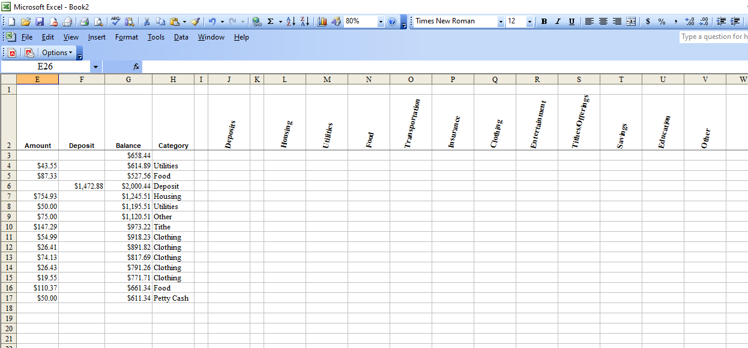
Hey, wait a minute—that isn’t right! There isn’t anything in the column labeled Deposits. What’s wrong? Look carefully at the entry in column H: it reads Deposit, not Deposits. Although there are other ways of addressing this, just correcting that entry is enough to do the job. Adding the extra letter works, and here’s what I get:
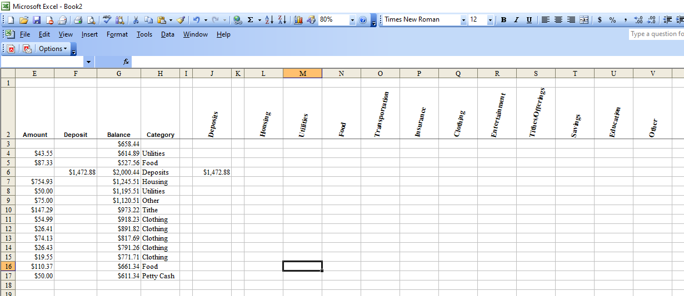
That’s a whole lot better! Tithe didn’t get fixed, because it needed reset to Tithes/Offerings; I’ll fix that, too. You will notice, by the way, that I took the time to format things so that the cells will display any numbers as currency.
Having succeeded in getting that to work for Deposits, let’s get a formula in place for the rest of the entries, other than the category Other: for that, we’ll use another formula.
This is what we entered in cell L4. =IF(L$2=$H4,$E4,"") See if you can figure out why I put that $ where I did, and what might happen if I forgot to do it. I copied the cell’s contents across the row, then copied the group of cells in the row down the many columns. This is what it looks like when I have it filled in:
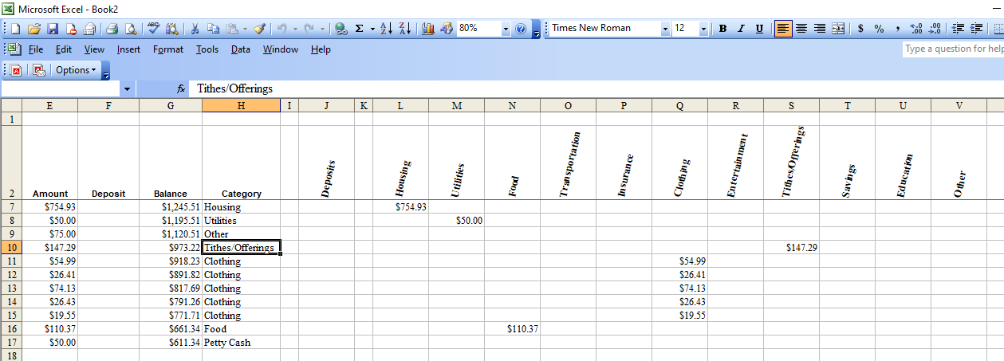
That’s awfully nice! Still, there’s that category “Other” that is still open. Rather than put “Other” in the Category column (as you see I did in cell H9), it might be nice to put in whatever the check is for and let EXCEL put the thing in the “Other” column if what’s in it fails to match any of the column headings. The way to do that is to see if there is any entry in columns L through U. In EXCEL, there is a function called “count” which counts the number of entries in whatever entries you specify. If “count” is zero for the row stretching from L to U, then you need to put the amount of the expense in the “Other” column.
To specify an area for count to do its counting, you pick the cell at the left, upper corner of what you want, type it in, then type a colon, then the cell at the right, lower corner of the area. So, to count the number of entries in the cells L4 through U4, you would type: =COUNT(L4:U4). If you wanted to get several rows, say all the way to row 10, it would be =COUNT(L4:U10), et cetera. I’ll put that in place, and show you the result:
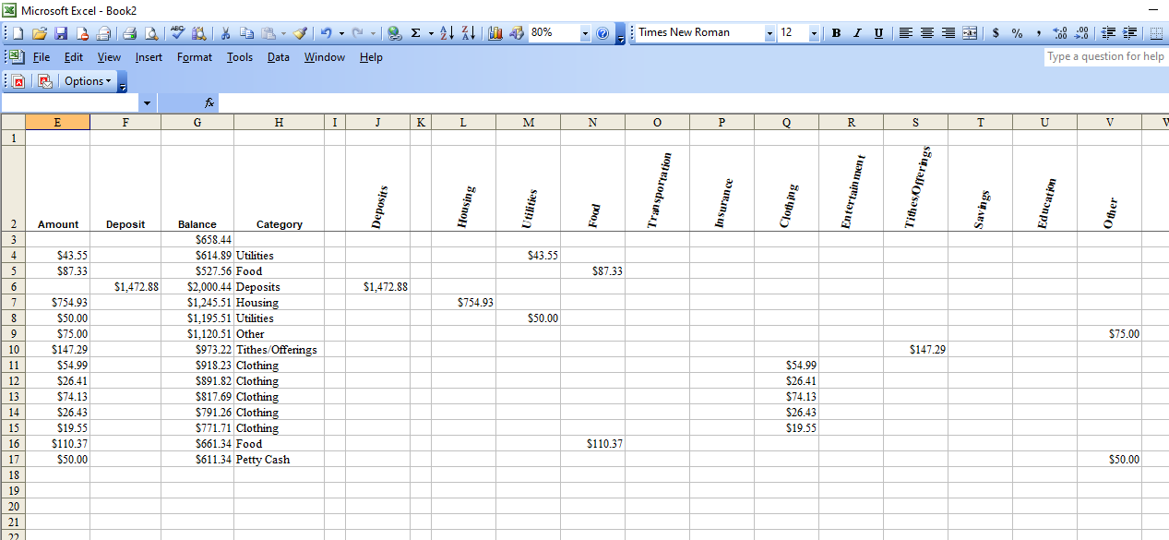
OK, the entry in row 9 is payment to CLI, and it should be labeled Education—I need to fix that. It also might be helpful to know what the totals are for each column. I’ll format a row to have a background color to make it look like the line you draw at the bottom of a column of figures, but above the sum, and I’ll use another handy EXCEL function called sum: it adds up everything in the cells you tell it, and you use the same way of specifying that as you did for the function “count” in the earlier example. If you want to add up all the entries in column L from row 4 to row 30 it would be: =SUM(L4:L30) et cetera. Here’s what the result looks like, with the correction made on line 9.
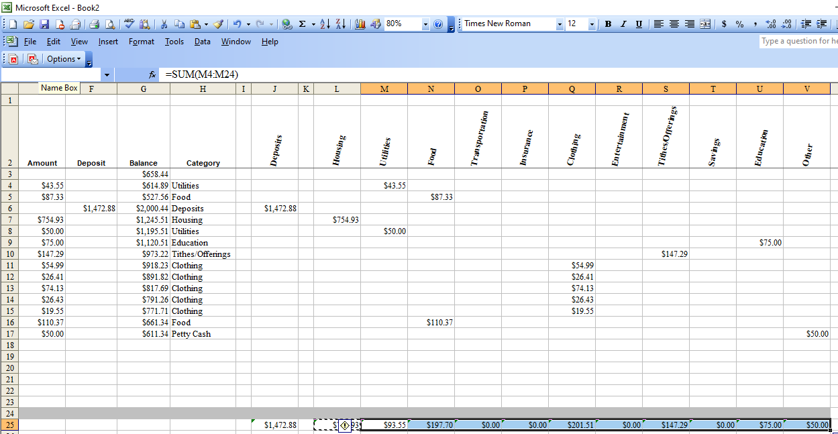
Now, row 24 is just that grey bar I created by highlighting B24 to V24, clicking on Format, then Cells, then Pattern and picking out the grey I wanted. Why did I choose to include that in the sum? Simple! I can now insert lines below line 23, but above line 24 and EXCEL will adjust the area in the parentheses for sum() to include those extra rows. Convenient!
At this point, you have built yourself a fairly powerful tool for keeping track of income and expenses and knowing where the money goes. As you have hopefully noticed, when you make a correction to an entry in any of the cells, or when you add a new entry, the spreadsheet updates itself automatically, to tell you the corrected or the new totals, and it moves the entry to the right column based on what you have in the Category column. Beware! This is not only quickly corrects mistakes and thus the spreadsheet, but also equally quickly makes them, messing up the whole spreadsheet. There is, however, an icon that looks like an arrow wound counterclockwise. That’s the “undo” icon. Click on that, and whatever you last did will be undone—and you can undo additional things by clicking it more than once. The “undo” icon can be an utter lifesaver!

