Unit 2: EXCEL

It probably seems a little odd to have a course in mathematics have a unit on using a spreadsheet. I confess, when I agreed to update this course, I felt the same way about that, but as I have thought through it, especially as I have constructed the EXCEL spreadsheet involved in this lesson, what I have realized is that using a spreadsheet teaches a specific analytical, critical approach to a problem—the same sort of critical, analytical, detailed approach that mathematics targets, as well.
In the past, when someone had an account to manage, the commonest approach was to take a wide sheet of paper that had been marked off in rows and columns to record activity. Usually, the first column was the date of a transaction, the next column what sort of transaction it was, next the amount of the transaction and then a running balance after the transaction. Often there would be several other columns, carefully labeled to indicate various kinds of transactions, with the entry put into the appropriate column. At the end of the day, or perhaps the week or month, a final balance would be calculated and totals for each column would be determined as well. I have no doubt that the people maintaining those large sheets occasionally wished that the sheet would update the totals when the entries were made.
Spreadsheets, like EXCEL, do exactly that. Windows, Apple and Ubuntu systems all have their own versions of spreadsheets, but we will be working in an older version of EXCEL. The main difference between spreadsheets will usually be where you have to look to find what you need, and for most of the things that we will be doing in this module, the systems will all function pretty much the same. Also worthy of note: some of the spreadsheets, particularly the Open Office spreadsheet, use semi-colons where EXCEL uses commas. If the formulae here don’t pan out on the spreadsheet you are using, that’s the first thing to check after you have double-checked that the formula is properly entered.
By no means will this module make you a master of EXCEL, nor should you expect it to do so. The module will focus on the tools and the tricks that will allow you to build a spreadsheet that will help you track your ministry money, or your personal finances, as easily and accurately as possible. Although it is not likely true, this module will build from the assumption that you have never seen a spreadsheet before.
On the off chance that you do not have a spreadsheet program, you can download a free spreadsheet, with a word processing program, a database program and a program that will let you create presentations, from:
https://www.openoffice.org/download/
All of the things referenced in this unit will be available in Open Office, newer versions of Microsoft Office (which contains EXCEL) and in other spreadsheet programs; they just may be in a different place and may use slightly different punctuation. Thankfully, there is always a place where you can ask for help and find out what you need to know.
Here’s what my empty EXCEL spreadsheet looks like.
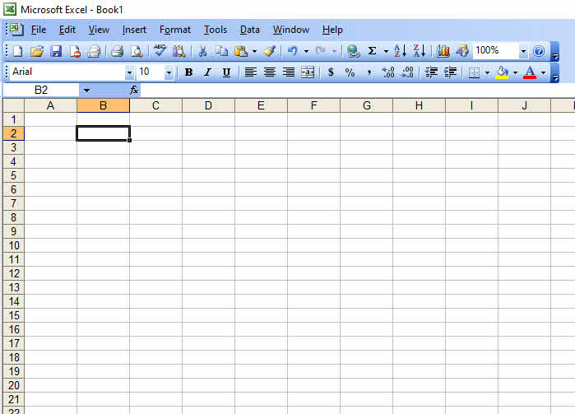
Across the very top of this, with a white background, you’ll notice a green X in a box, followed by Microsoft Excel – Book 1. This is the ribbon that tells you you’re in EXCEL, and the current spreadsheet is called Book 1. You’ll learn how to save the file and give it whatever name you like later on in this module.
Under that ribbon, there is a blue ribbon, with the words “File,” “Edit,” “View,” “Insert,” “Tools,” “Table,”, “Window” and “Help.” Each one of those, if you take your cursor onto them and click, will give you a listing of things you might want to do. To do the thing in any of them, you click on what you want and EXCEL will help you do it.
Below that ribbon, there are ribbons with pictures—they are called “icons” in the computer vernacular—each of which represents a possible task. For our purposes, only a few of them will be important, and as much as possible we will work with the ribbon with the words on it.
Finally, there is a ribbon that has a white space with a letter or two followed by a number, then another open space. The letter plus number place tells you what box you last clicked with the cursor. That open space will tell you what is in the cell.
Under that, you’ve got the ribbon with the letters, going from A to Z, then AA to AZ, BA to BZ et cetera, and on the left side, you’ve got numbers going down the side of the screen from 1 to up to 65,000 or so. Each cell is identified by a letter or two followed by a number. As you can tell, the last cell I clicked was B2. It is also the one cell surrounded by a heavier boarder, and there appears to be nothing in it.
Click on B2 on your program, and type in a number. Go down to B3 and type in another. Keep going down, typing in numbers or letters and see what you see. Note that you can go to the next cell down in a column by pressing the “enter” key. If you want to move to the right, you can use the tab key. With both keys, what you entered in the cell you just left will be stored just as you typed it. Later, we’ll look at formulas and other useful things: what you will see is the value the formula or whatever has produced.
I typed some things in, and my screen now looks like this.
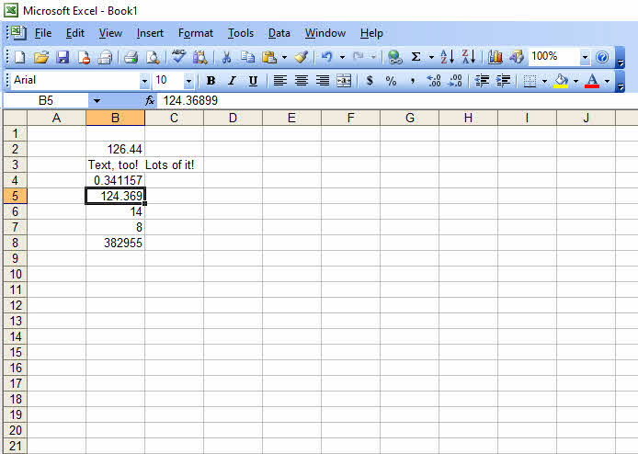
Nothing much useful, here, but it makes a couple of points. The last box I clicked on with the mouse was obviously B5. What the spreadsheet shows in that cell is 124.369, but the contents in that line above is 124.36899. EXCEL has rounded the number for display purposes, but the cell still contains the original entry. This can be an issue in some calculations! Also notice cell B3. It has some text in it, and the contents of the cell extends into cell C3 as well. If I put something in cell C3, however, the displayed text extending over would be covered by whatever I put in C3—but it would be unaltered in B3.
OK, this is all well and good, but this isn’t much help. Let’s clear the screen and see what useful things we can do. Let’s start with creating a simple register for a checking account. We’ll want a column for the check number, a column for who the check was written to, a column for how much the check was for, a column for deposits made—that won’t need a check number, by the way—and a running total of what’s left in the checking account. Here’s the starting point!
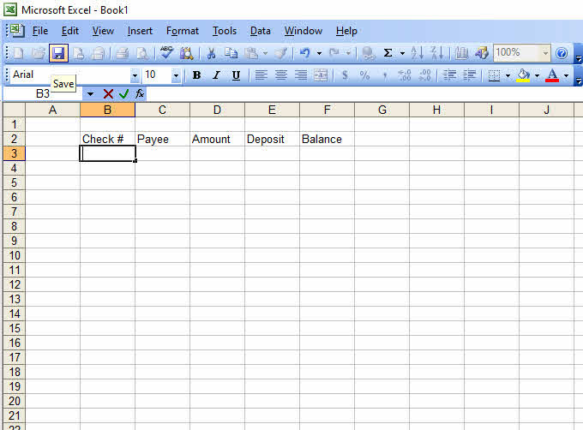
Not bad, but it’s not all that pretty. It would be nice if those titles for the column were in the middle of the cell, wouldn’t it? We can do that! Notice the icon at which the icon is pointing. Here’s what you can do. Click on cell B2, then move the cursor over to cell F2, hold down the shift key and click.
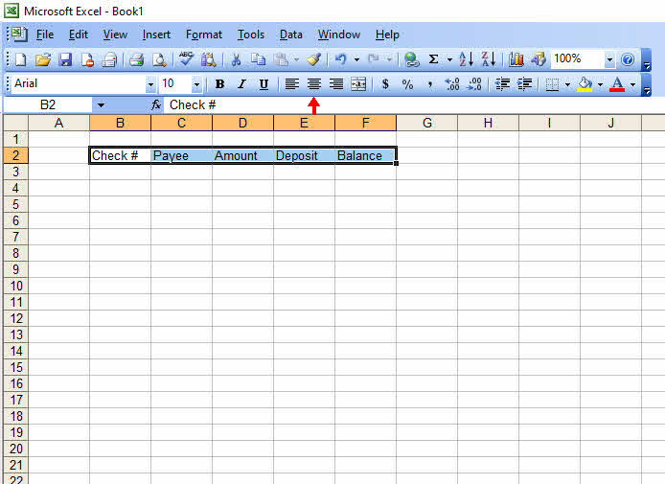
Now, click on the icon to which the little red arrow is pointing—you will see the icon, but your spreadsheet won’t have the arrow, of course. When you’ve done that, you should see something like this:
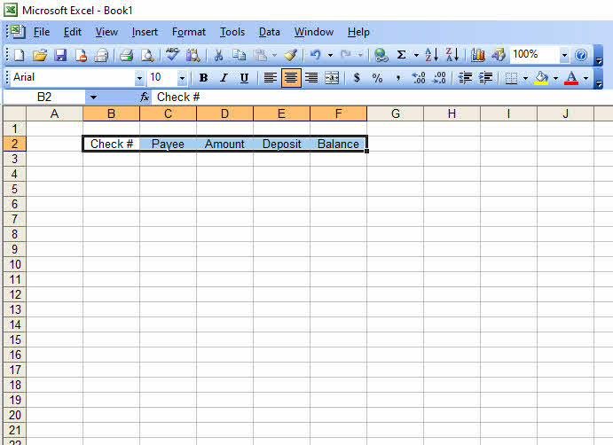
It’s better, but there isn’t a lot of room for the name of the payee. Again, that’s fixable.
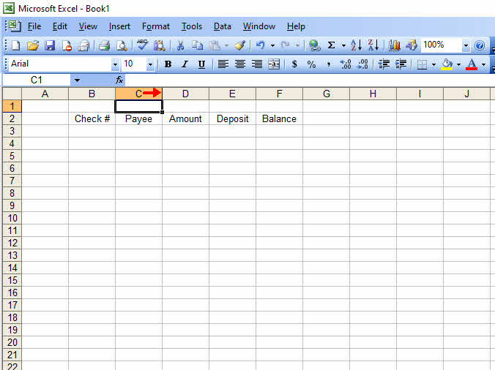
Notice the line, just to the right of the letter C—the one the red arrow is indicating. Move your cursor until it is just over that line—it’s easy to recognize, because in EXCEL the cursor will suddenly look like a vertical black bar with black arrows pointing to the right and left—and hold down the left mouse button. While still holding the mouse button down, move the cursor to the right. Viola! The column widens as much as you want! You can go to the same bar on column A and shrink it down—just move the cursor to the left rather than the right. This is how my spreadsheet looks after I’ve done that.
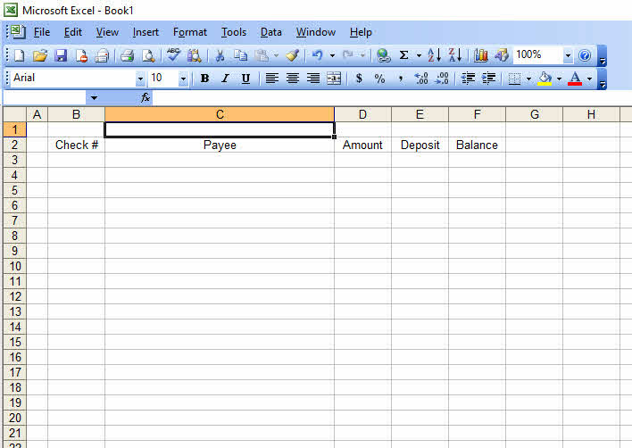
This is starting to look like we might get some use out of it, after all. Let’s start by putting in a few checks, and an initial balance, and maybe a couple of deposits. Here is what I did.
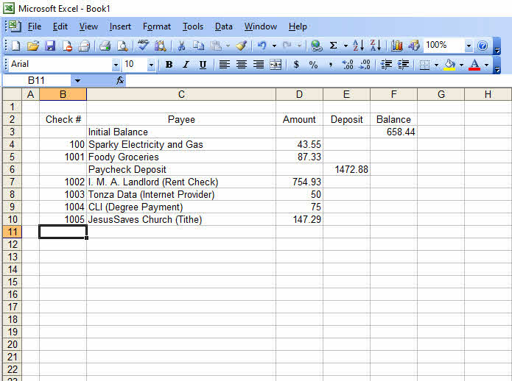
Interesting, but not very useful, yet. Now, let’s see about getting this spreadsheet to do something. I’m going to click on cell F4 and enter a formula. Here’s what happened. Notice, the contents of cell F4 is a number, but up on that bar above, there is a formula.
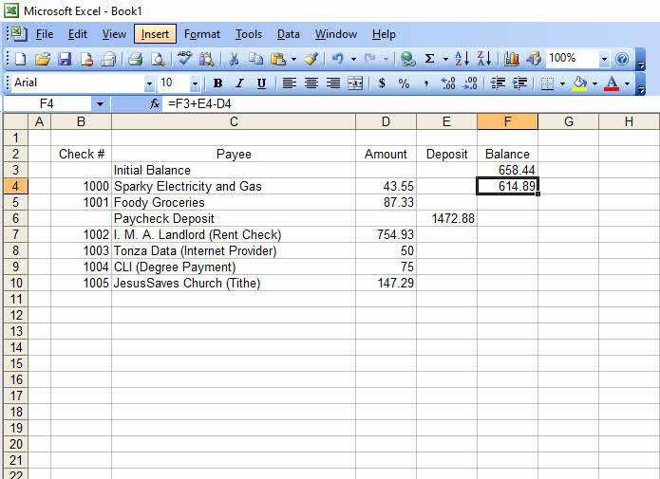
Let’s interpret that formula in the white area after fx in the picture. The equals sign, = , alerts the spreadsheet that I’m putting a formula in place. F3 tells the spreadsheet to take what is in cell F3. +E4 tells the spreadsheet to add on anything in cell E4. –D4 tells it to subtract anything in D4 from the total. What you see in cell F4 is the result of that calculation. Now we’re getting somewhere! It did my arithmetic! But do I have to do that formula for every cell?
Well, yes and no. You can copy the contents of cell F4 into other cells, and the spreadsheet will adjust the formula to reflect the new position. The first thing you need to do is click the mouse on the cell you want to copy. Hold down the control key—it’s usually on the left side of the keyboard at the very bottom—and then press the c key. Move the cursor to the place where you want to start copying, then push the shift key and pull the cursor down as far as you want to copy. Here’s what it should look like:
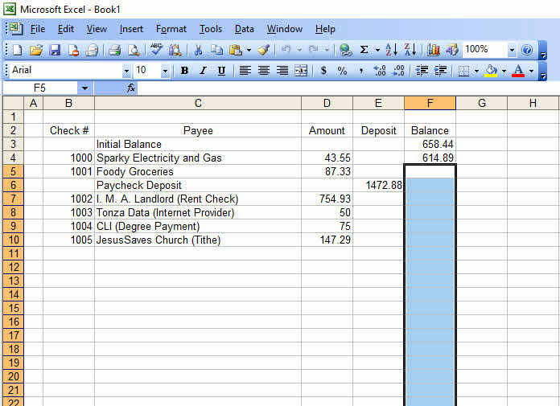
Just so you know, the cell you will be copying will have an animated border on it that does not come across when I do the screen shot. That said, you now hold down the control key and press v. The spreadsheet will now fill in the highlighted cells with the result of the calculation. This is what I get:
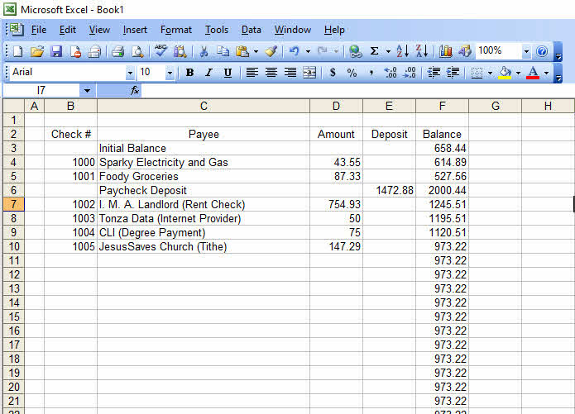
Well, it’s done its arithmetic just fine, but the calculations go on and on even though there’s no calculating needed. That’s sort of messy. That’s something that needs to be cleaned up. Basically, if the cell in column D and the cell in column E are empty, we don’t want the computation to put anything in the cell, but if one or the other of the entries isn’t a blank, we do want to do the computation and put the result in the cell. There is actually a command in EXCEL that will let you do things based on a decision. Guess what? It’s exactly what you would think: IF. OK, you have to have parentheses, as in IF(this is true, do this, otherwise do that), but it’s IF. Easy to remember. As for checking if one of two or more situations exist, guess what the thing you use is? OR(thing1, thing2, thing3, etc). How about making sure all of a number of things are true? Here’s the shockeroo: the command is AND(thing1, thing2, thing3, etc) Let’s set up our spreadsheet so that it checks to see if either the entry in column D isn’t equal to zero, or the one in column E isn’t zero, and then calculates the total when one or the other isn’t zero. I’ll construct the formula and copy it down the column and show you the result.
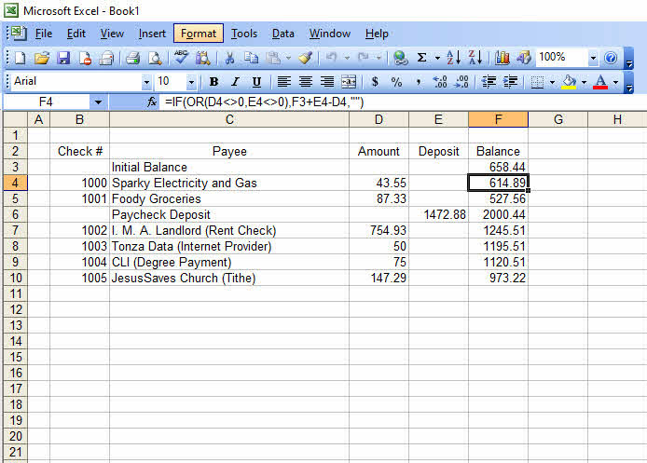
There are a few things to notice, here. First thing: I need that equals sign in front of the IF. Anything you do that will require computation, you have to start that line with an =. Next, notice that I put in the OR thing: inside the parentheses I have put D4<>0. <> is used to mean “not equal to”, and this is going to read out as “true” or “false” to the computer, depending on whether D4 is zero or something else. Then there is a comma, and E4<>0, which is either true or false depending on what’s in E4. Even though I have only two entries here, you can put in more—I just needed two. As long as you separate the different true/false tests with a comma, you can have almost as many as you want. Of course, to let EXCEL know I’m done with the OR testing, I have to close the parentheses. Then comes another comma, followed by what I want done if either of the things in OR are true—the formula. What comes next is what I want put in the cell otherwise—a blank space. "" means a blank or empty cell. Also, this is being done in EXCEL; in OPEN OFFICE, you’d use a semicolon rather than a comma. So, the final computation command looks like this:
=IF(OR(D4<>0, E4<>0),F3+E4-D4,"")
Just to show you how it might be done with the AND testing, I’ll rewrite the file using that. Here’s what you get:
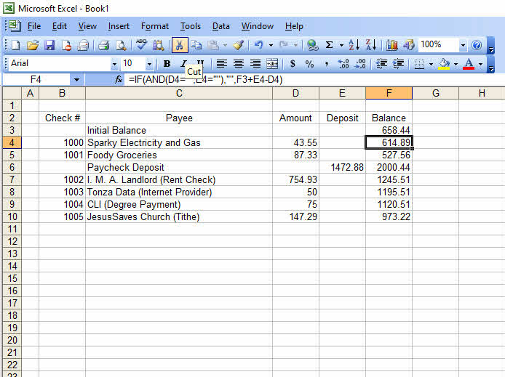
That’s =IF(AND(D4="",C4=""),"",F3+E4-D4) I’ve told EXCEL to see if both the entries in column D and column E are empty, and if they are, leave column F empty; if not, to calculate the formula. Again, in OPEN OFFICE, the formula would look like this: =IF(AND(D4="";C4="";"";F3+E4-D4)
So far, so good: you’ve seen how to get a spreadsheet to do your arithmetic, and even how to leave a cell blank if there is no need for a new computation. Still, things aren’t really all that pretty: notice that 50 and 70 in column D. They should be $50.00 and $70.00, right? Or whatever symbol is used for currency where you minister. For that matter, how about having all the other financial entries have that $, or whatever you use, in front of it. That really would be better.
Up at the top of the screen is the word Format. Click on it. This is what you will see. Again, in different versions of EXCEL or in different spreadsheets, you may have to click on something else, somewhere else, but it will be there.
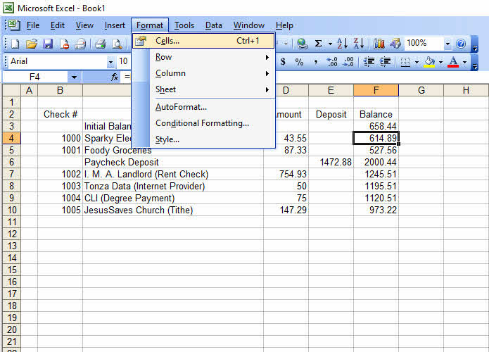
Click on the entry Cells. You should see something like this, depending on your spreadsheet:
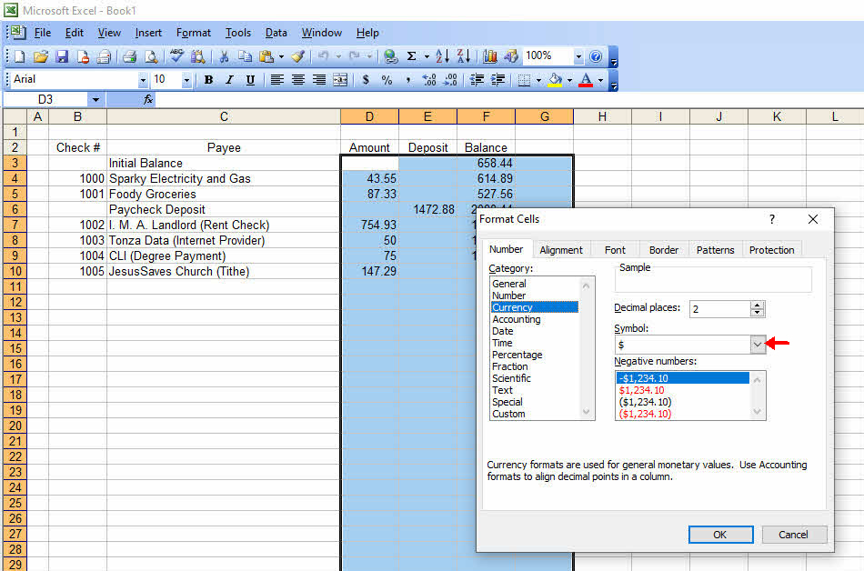
I’ve clicked on Currency here. Now that little red arrow I’ve added, pointing at the downward pointing arrowhead, is something you can click on and get to choose between whatever currency you want. It’s got a lot of currencies in it, and whatever you choose, it will display as the currency requires. I left it dollars. Note also you can choose how to have negative numbers displayed—red numbers are popular for when you have less than no money, which is where the phrase “being in the red” had its origin.
Notice also I’ve highlighted (click; hold shift while holding the click; move the mouse to cover the area to be modified) an area before I started doing all of this, to tell the computer where I want it to set things up the way I choose. Here’s the result:
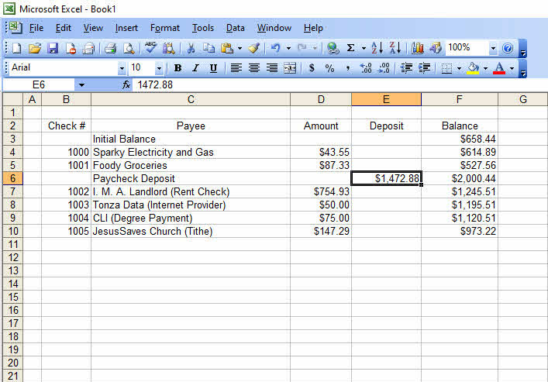
Please notice that fx area. Cell E6 has the dollar sign, but the contents of the cell, as displayed in the fx box remains exactly as I entered it. This is important to notice: reformatting the cell only changes how the cell is displayed, and does not alter the actual contents of the cell.
Hold on a second! I did a big old goof, here! I forgot to put in a column for the date of the transaction. Have I totally wasted my efforts, and now have to start all over again? Thankfully, no. I can ask EXCEL to add a column between columns B and C. I’ll show you how. Click on some cell in column C and then on the word Insert up at the top. You will see something like this:
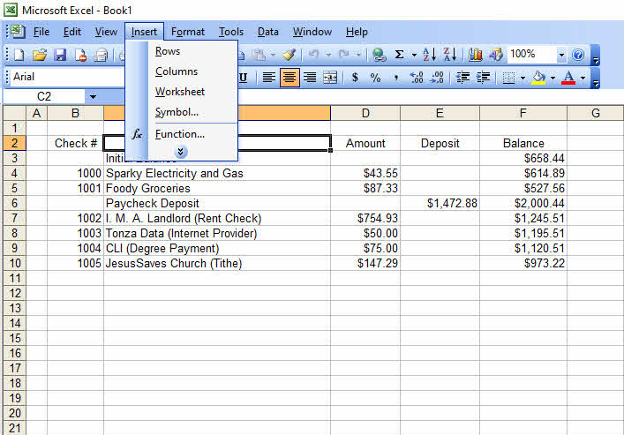
Click on Columns, and you’ll suddenly see a new column C, between what used to be columns B and C. I’ll label it Date, and I’m going to change Payee to Transaction. Here’s what you should see.
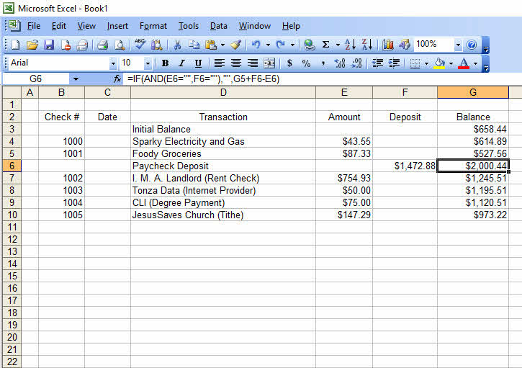
There is something very important to notice here. Although I have created a new column C, the Balance column remains correct. If you look at the formula in the fx entry, you will notice that the contents of cell G6, once cell F6, has been adjusted to reflect the presence of the new column. It’s nice to know that EXCEL will do this for you, whether you add rows or columns—but on occasion, it can cause trouble, as well. The new rows or columns inserted will be totally blank, and EXCEL will adjust all the other rows and columns to jump around the new material.
Next, click on the C to highlight that column, then click on Format then Cells. Click on Date. You’ll see a number of different ways that EXCEL will display a date.
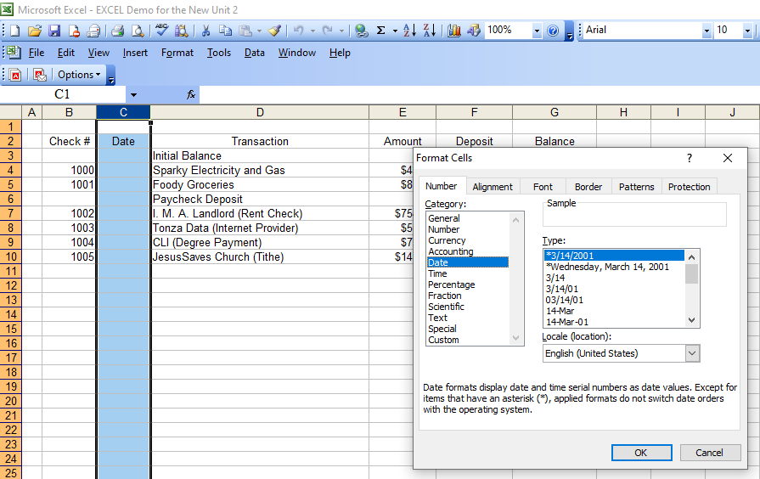
I’ll pick my favorite and fill in some dates. I’ll fill in a number of additional entries, as well, so there is more with which to work. Here’s what I have done
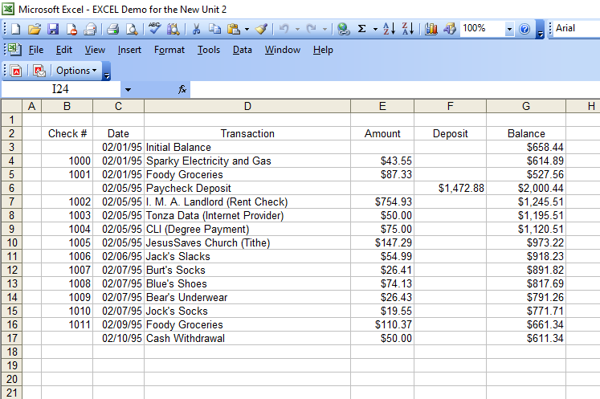
Looks like someone’s been buying a new outfit or two.
Now, click on the 2 on the left to highlight the whole row then on the B. I’ve already clicked on it, and it’s orange. You’ll see this:
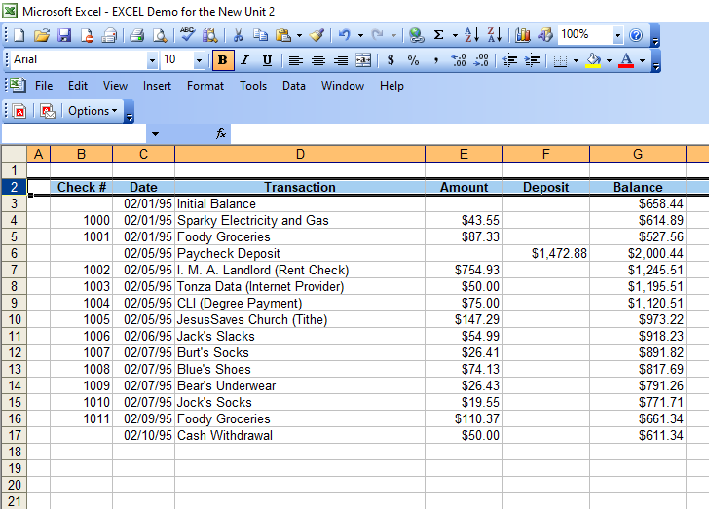
That B stands for “Bold” which, as you can see, makes the text in row 2 show up in a bold font. By the way, the I to the right of the B, which is in italics, will convert text to italics. The U to the right of that I will underline the contents of the cell. Note that if a cell’s contents are bold, clicking on that B will undo the bold, if they are in italics, it will return them to the standard font, and if they are underlined, clicking the U will remove the underline.
Ultimately, you’ll run out of rows on the screen, but you’ll still want to see those headers in row 2. EXCEL has made provision for that, too! Click on cell A3, then click on Window in the blue text ribbon. This is what you’ll see
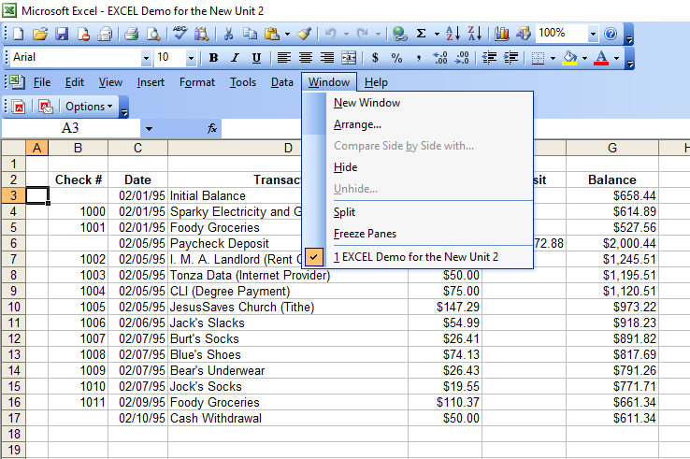
Click on Freeze Panes. If you look closely, you will see that there’s an enhanced line between row 2 and row 3.
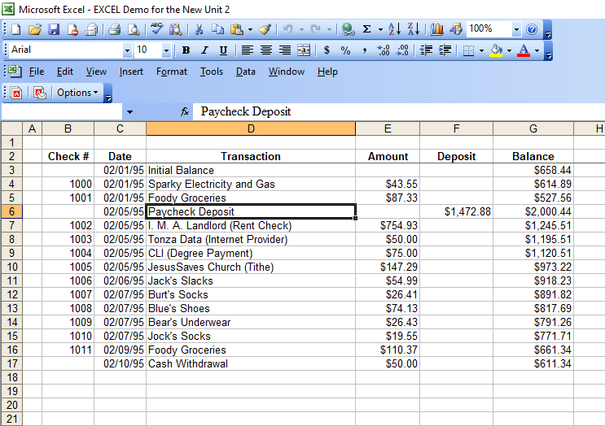
This is where you scroll down the screen, either using the down arrow, the page down, or the slider on the side of the frame you are seeing. I’ll do that and show you what I get.
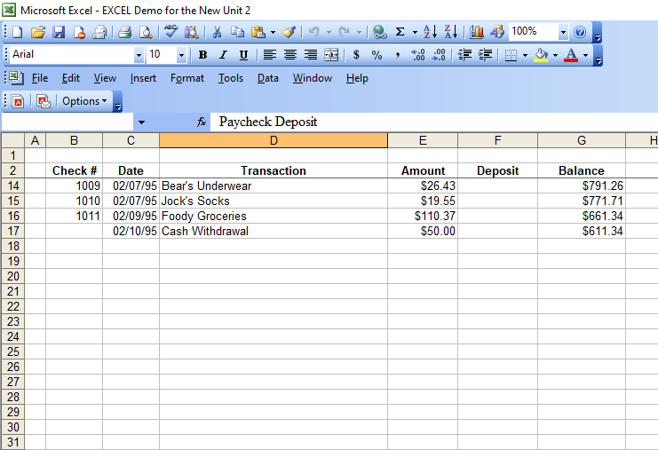
The lower part of the display has scrolled, but the top two rows have not. Data in the rows has not disappeared; you can scroll the screen the other way, and they will reappear. Notice up in the fx box above: EXCEL still has me in the cell with Paycheck Deposit in it, and that is what it displays.
This has been a lot of information, but let’s do one more thing: store the file. Click on the word File in that ribbon. You should see something like this:
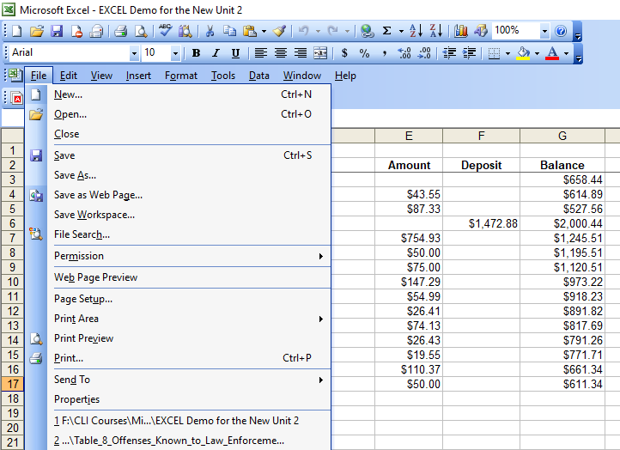
Among the choices offered, you will see Save As… Click on that, and see something ike this:
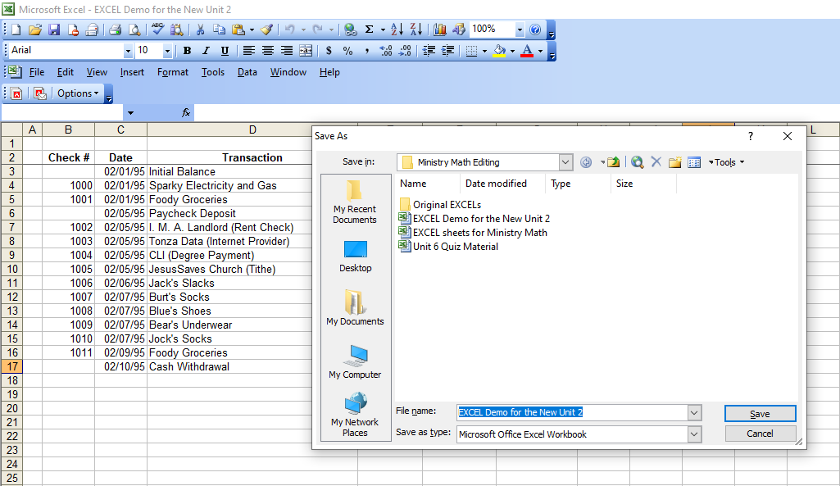
Up at the top, you can see a box labeled Save to: which is where you choose the file in which you want to save the work you’ve done. File name: is a box on the bottom; type in whatever you want to call the file. I’m calling it a really creative name: EXCEL Demo for the New Unit 2. OK, maybe it’s not really a very creative name, but it tells me what the file is all about. That way, I can find the file more easily when I want to add more entries.

