Unit 7

Many of the people taking the Finite Math course will be preparing to be bivocational—there will be the ministry God is called to, or is calling to, but there will also be a second vocation that will be supporting the ministry and paying for personal needs, such as food, shelter and the like. Some of those bivocational individuals will have their own businesses or will be starting their own business. This unit will look at issues that will be helpful in that context.

Invoices
This material is condensed from: What is an invoice? From Wikipedia, the free encyclopedia.
An invoice is a commercial document, issued by the seller to the buyer, relating to a sale transaction, indicating the products or services, quantities and agreed prices for the products or services the seller had provided the buyer
An invoice would generally contain:
- The word Invoice (or Tax Invoice).
- A unique reference number (in case of correspondence about the invoice)
- Date of the invoice.
- Credit terms
- Tax payments if relevant (e.g. the Government Sales Tax or Value Added Tax)
- Name and contact details of the seller
- Tax or company registration details of seller (if relevant)
- Name and contact details of the buyer
- Date that the goods or services were sent or delivered
- Purchase order number or similar tracking numbers requested by the buyer to be mentioned on the invoice
- Description of the product(s)
- Unit price(s) and number of the product(s) to be provided (if relevant)
- Total amount charged (optionally with breakdown of taxes, if relevant)
- Payment terms including:
  - method of payment
  - date of payment
  - details about charges for late payment

Other items, such as the seller's company logo, may well be included on the invoice. The invoice serves two purposes: it informs the buyer what needs paid—for some transactions, this may have been paid in advance—and also provides a record of the sale and its cost both for the buyer and seller. Both of these can be important for financial record keeping.

A purchase order is very similar to the Invoice, but it is a list of what you are wanting to purchase. It will have the same general structure as the invoice, with a few modifications
- The words Purchase Order
- A unique reference number, the purchase order number
- Date of the purchase order
- Tax payments if relevant (e.g. the Government Sales Tax or Value Added Tax)
- Name and contact details of the buyer
- Tax or company registration details of seller, or tax-free status (if relevant)
- Name and contact details of the seller
- Date that the goods or service are agreed to be delivered or rendered
- Shipping method
- Description of the product(s)
- Unit price(s) of the product(s) (if relevant) and number desired
- Total cost of order (optionally with breakdown of taxes, if relevant)
- Payment terms including:
  - method of payment
  - date of payment

Definitions for a Profit and Loss Statement

DEFINITIONS:
REVENUE is compensation received for your product or services.
COST OF GOODS SOLD are the variable expenses related to the sale of your product.
OPERATING EXPENSES are fixed expenses, such as rent, and utilities.
OPERATING INCOME is profit after operating expenses are deducted.
EARNINGS BEFORE TAXES is income including other income and expenses, but before taxes.
INCOME TAXES are federal, state, and local taxes.
NET EARNINGS is the profit earned by the business, and it includes all expenses, including taxes.
Revenue – cost of goods sold = Gross Profit – Operating Expenses
= Operating Income + Other Income - Other Expenses
= Earnings Before Taxes – Income Taxes
= Net Earnings

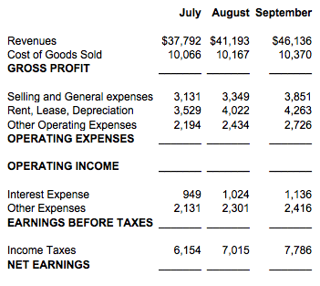

ANSWERS

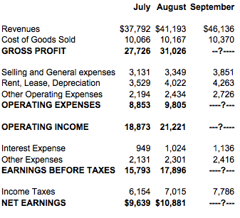

Spreadsheet notes

Let’s bring up your spreadsheet. Here’s the image of my older EXCEL.
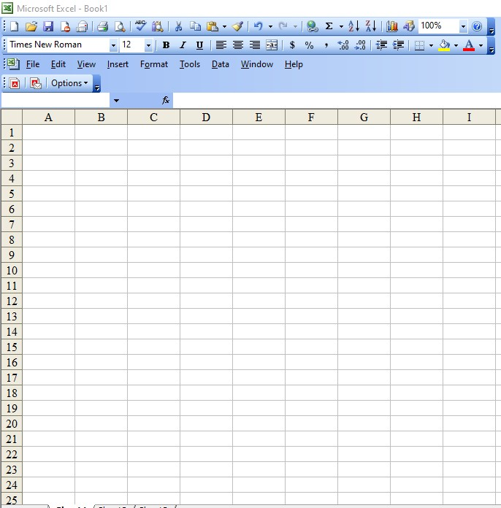
I will assume that you still remember what you learned in Unit 2 and won’t explain it in detail. Again, I realize that you may be using a different version of EXCEL, or a different spreadsheet program altogether, but what is done here will be possible in other spreadsheet systems, even if it may be somewhere else in the taskbar or ribbon, or perhaps spelled slightly differently.

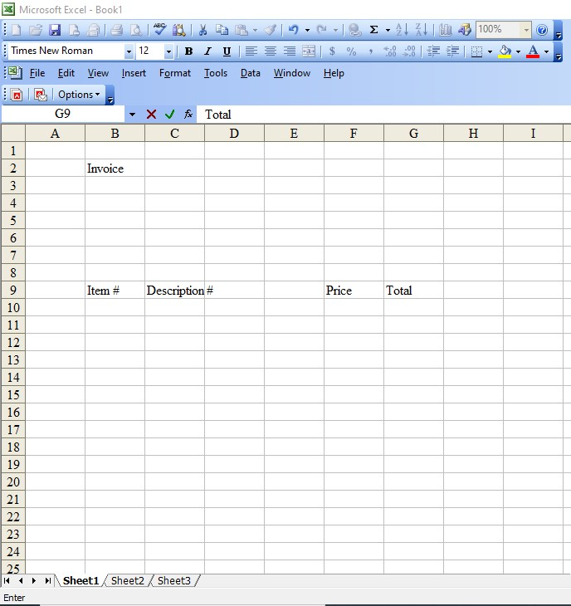
For this lesson, we’ll build a general invoice, and a general purchase order, one that you can fill out for each individual sale or purchase. If you use this sort of resource, it would be in your best interest to access a virtual printer that will print your spreadsheet invoice to a .pdf file that you save for future reference, using some naming structure that identifies the invoice in a way that makes finding it in the future an easy task. In some contexts, you might even be able to eMail the .pdf document to the individual or company involved, saving the cost of printing it out and mailing a paper invoice or purchase order. There are several freeware applications that will let you print to a .pdf file; OpenOffice is a full-featured, freeware version of Microsoft Office that already has the capacity to print to a .pdf file, and the most recent version of Microsoft Office has that ability as well. It is, I think, something worth considering.

Let’s start by building the invoice. It needs labeled as an invoice, and it needs columns that identify what the item number—here in the USA we call that a SKU number though I haven’t a clue what SKU stands for—a description of what the item is, how many were ordered or bought, what the unit price for the product is, and the total cost for each line.

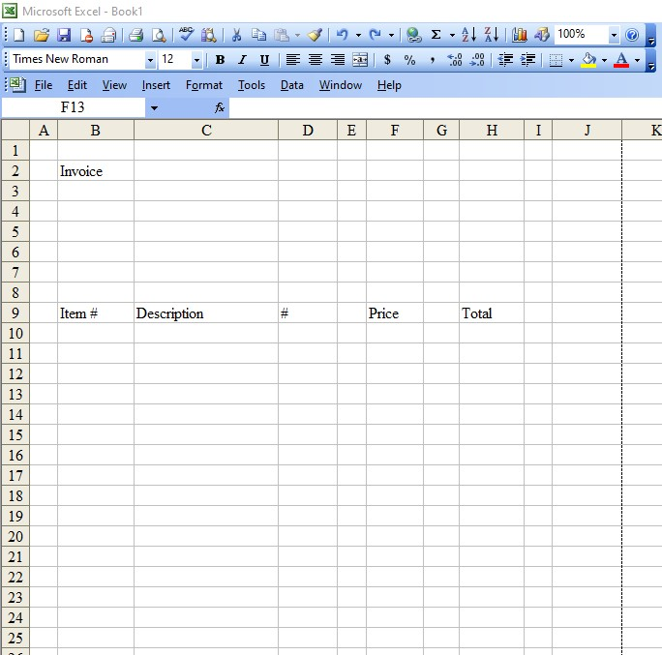
This is how I put it together, so far. You’ll notice a blank column, column E; I plan to insert another blank column between columns F and G here in a minute. That little menu called “Insert” is how to access that. I will also want to do some adjusting of the column width—put the cursor over the line between two letters at the top, press and hold the left mouse button, and move the line to where you think you want it. What is necessary here is to find out what width I have with which to work, and still be on a single page. There is a simple way to convince EXCEL to do that: click on the File menu, then on Print Preview. You’ll see what your page would look like when it is printed—it won’t be very impressive at this point, but when you close the Print Preview, you will notice a minor change in the appearance of the display. Between columns J and K, running down the page, there is a dashed line. Although you can’t see it on this image, there is also a dotted line running across the page between a couple of rows further down the spreadsheet. Those dashed lines mark where EXCEL will put the right edge and the bottom of the page when it finally prints things out. That’s extremely useful to know when you start adjusting the width of the columns, and when you think about where to put material at the bottom of the page. Remember, the appearance of the invoice or the purchase order greatly affects how the recipient will view your business, whether or not that is reasonable.

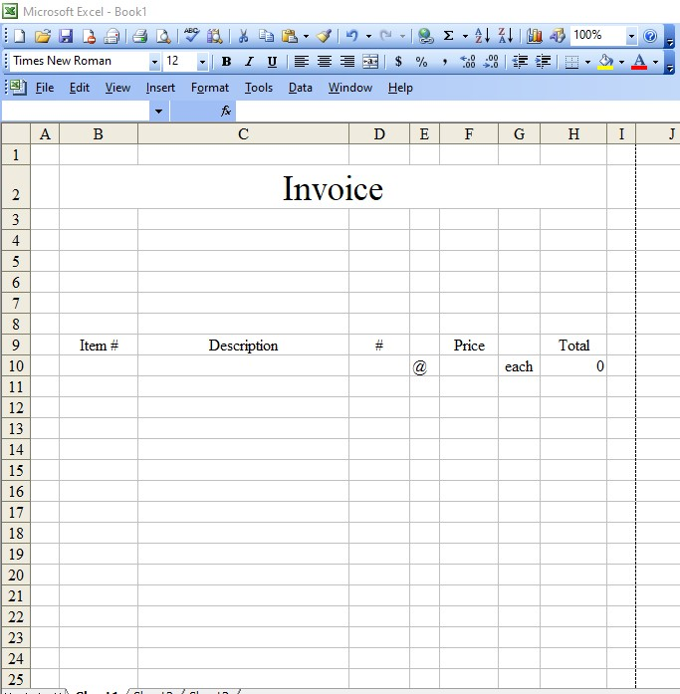
Considering the appearance of the invoice, it would probably be much more appealing to have the word “invoice” centered across the top of the page. I’ve set things up so that I can use columns A and I as a border to the page, and using the Format menu, under the Cells option, I’ve merged the cells from B2 through H2, highlighting them, going to the Cells option and clicking on “Merge.” I’ve also increased the size of the font, and I’ve centered the word “invoice” in that much larger cell. I’ve also adjusted the column widths to reflect the size I think I will need on the invoice, and in row 10, I’ve added @ and each, then in column H, I’ve calculated the value of the entry in column D (the number sold) times the entry in column F (the price per unit) which is, at the moment, zero. The plan would be to highlight the entries from E10 to H10, copy them (holding down the control key and hitting the C key) to the balance of the invoice by highlighting the area in column E where want it copied, then holding control and striking V. The trouble with doing that is the unneeded @, each and calculations if there is no purchase ordered on the line. There should be no extra material on the invoice—it looks sloppy and clutters the invoice. Hopefully you remember the trick with the IF command. Here, you check to see if there is an entry in column F. If the row entry in column F is not empty, you calculate the value; if it is not, you put in a blank. Here’s what the command string you’d put in the box near fx would look like, for row 10:
For H10, enter: =IF(F10="","",D10*F10)
For G10, enter: =IF(F10="",""," each")
For E10, enter: =IF(F10="","","@")
Notice that I put a space before the e in each; it just makes things look better.

Having done that, I’ve adjusted the column widths to something that feels reasonable to me. The next thing we need to do is put together a place for the invoice number, for the date of the invoice, and for the person being invoiced as well as the name & address of your business. To make that happen, I highlighted some cells to be the “to” section, clicked on Format, then Cells and Boarders. All that is needed is the outside, so I clicked on the box that put the outside border in place. I did the same sort of thing for the “from” section as well. This is what the result looks like:
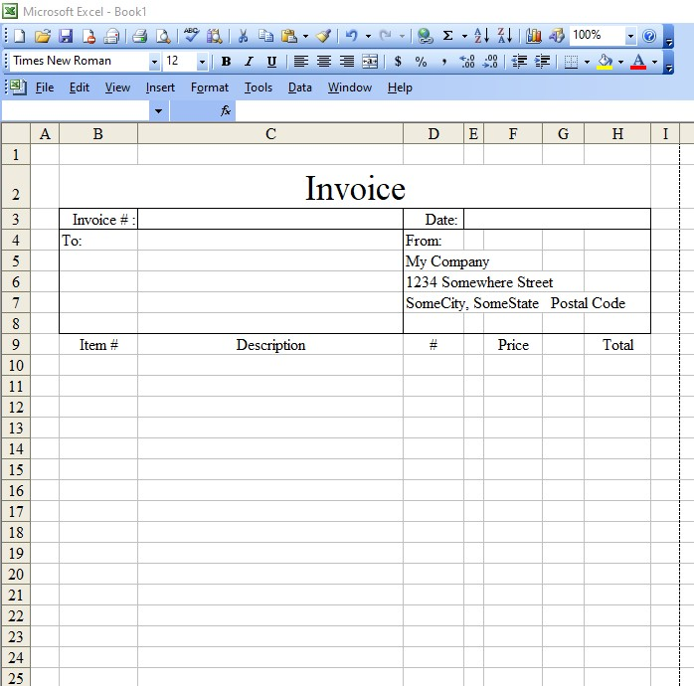
Starting to look more professional—but let’s make borders around the cells with boxes. It’s the same procedure: highlight the cells B9 through H9, click on format, then cells, then borders. We want borders between the different column titles, so it’s the outside border with the inside border, both. Now, cell E9 and cell G9 don’t really need the left hand border—you can click so you are in the cell, then do click format, cell and border. Along the side, you can see icons that represent different sides—above, below, right and left of the cell. Click on the one for the left side of the cell, and it will disappear. The result should look rather like the next screen shot.

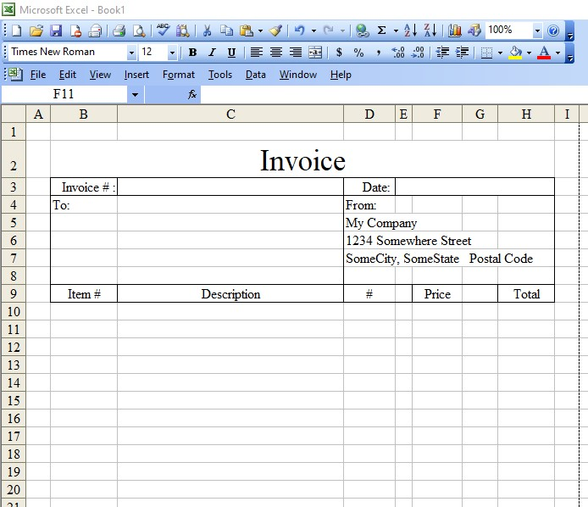
Things are coming together, I would say. Of course, with any individual invoice, you’ll be putting in the specific name and address of the recipient of the invoice, the invoice number and the date of the invoice for each invoice, and you’ll be putting the goods and services for the specific invoice in the area below. What we need to do now is put in the information that is pertinent to when you expect paid, and the penalties for overdue bills, to say nothing of the time when unpaid invoices go overdue. This is something that probably would be best put on the bottom of the sheet, maybe in large letters. What I did was take a block of cells, merged them, and written some text in a larger font. The numbers are arbitrary and are not at all suggestions for what you should say. I did not put anything in place concerning the means by which payment should be made, either, which is something that you may or may not want to put in place. Here is what this looks like when I finished this adjustment.

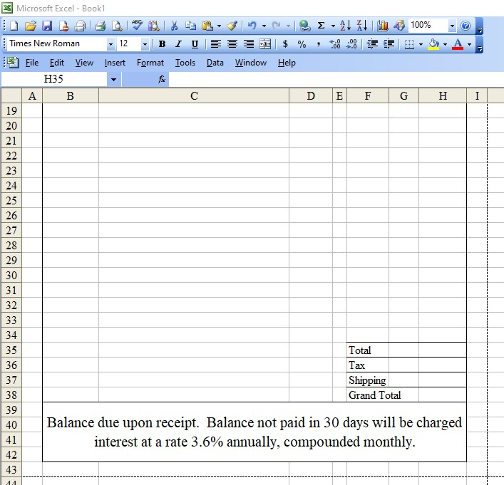
You will, I trust, notice that I put in a line for total cost, tax, shipping and a grand total at the bottom—lines above and below, which you should be able to format into place, now—as well as putting a border around the area for the entries in the invoice.

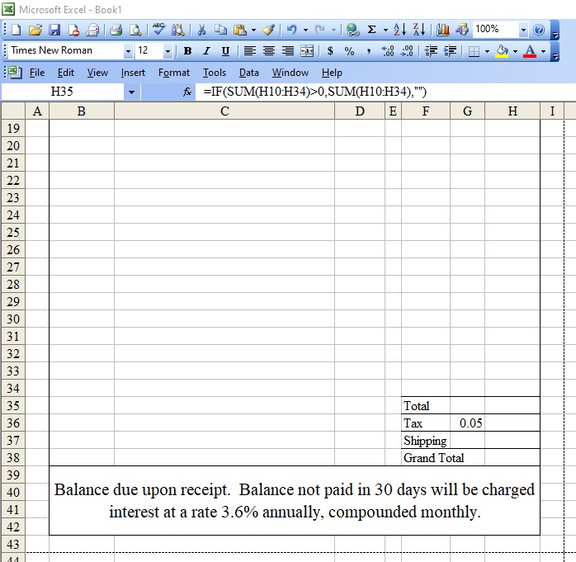
We need a total of the charges in the invoice, which would happen in cell H35; in the box near fx you can see the formula that was built to handle this: =IF(SUM(H10:H34)>0,SUM(H10:H34),"") which may need minor adjustments for the number of rows you have. The reason the test was on the sum of the cells is simple: you might not have put the first entry in cell H10. If I do my logical testing on the sum of all the cells from H10 to H34, having any cell with a positive entry will cause a total to be printed out. Next, we need to deal with cell H36—the tax entry. I picked 5% (as you hopefully recall, that is 0.05) to use as an example; you’ll have to use whatever your local rate seems to be. Here’s what the result looks like:

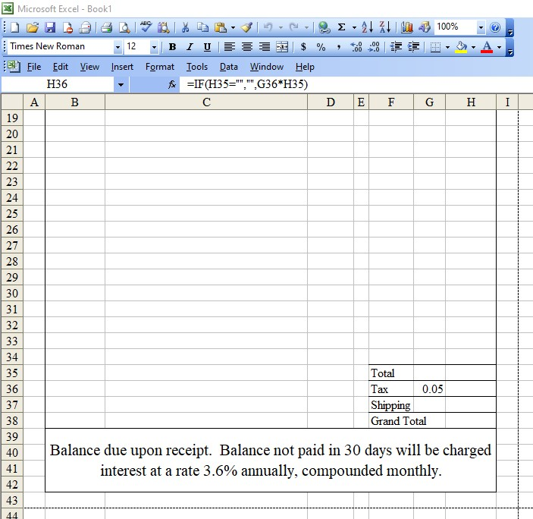

You can see the formula I’m putting in H36: =IF(H35="","",G36*H35). You might want that last entry to be rounded to 2 decimal places, so that formula might look like this:
=IF(H35="","",ROUND(G36*H35,2))
H37 does not have a clear formula I can use, so that is a cell that will be filled by hand. There are other tricks that might be useful, but they are outside the reach of this course. All that is necessary is to add the rest up and have a grand total. The bottom of the invoice looks like this.

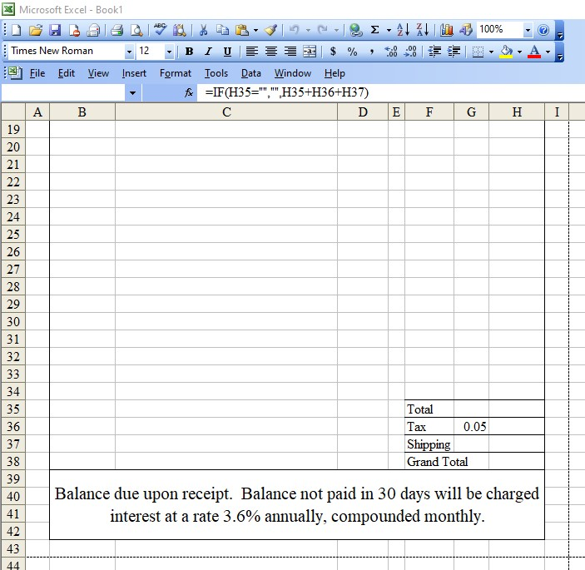
The formula in H38 is visible in the fx line: =IF(H35="","",H35+H36+H37) The only complex part of it is the logic test to decide if there is a blank space or a printed value. Of course, I could have used the SUM command, but with just three entries, I chose to do it the “hard” way. I’ll throw in some fun entries into the invoice and give you a shot of what the whole page looks like.

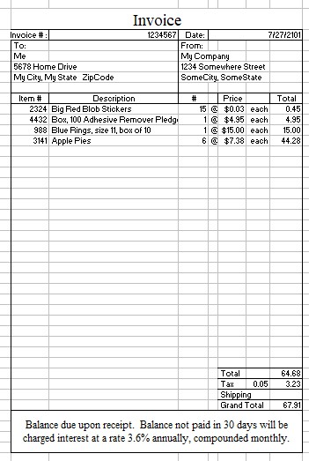
This isn’t exactly the way it will look on a printed document: the document will be a lot clearer and sharper, and the grid showing the actual cells will be absent. This looks professional, clean and makes you look good. Clearly, you might want to format the cells in the “Description” column so that they wrap—one entry was too wide for the column, as you may have noticed—and you might want to get the cells in the column “Total” reformatted to be currency, but it’s looking reasonably professional.

To convert this into a purchase order, you would replace “invoice” at the top with “Purchase Order”, and put Purchase Order # for Invoice #, clear the section on balance due (possibly putting information about how you plan to pay for the invoice) and the document is ready to be filled out as a purchase order.

Needless to say, this may not be of great use to many of you that are taking the Practical Math course, but the principals involved in creating it are valuable, and can be turned to an assortment of other, potentially very useful, tasks.

